Working protocol: MC applies the publicly verifiable direction of ISO/DIS 19650-1 and ISO/DIS 19650-2 (2026 drafts) to project information management. ISO 19650-1:2018 and ISO 19650-2:2018 remain the published references until replaced. The appointment and applicable national adoption determine contractual obligations. Generation does not constitute review, authorization, acceptance or certification.

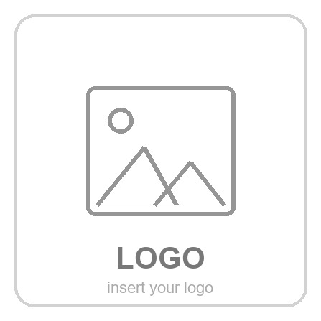  INFORMATION PRODUCTION STANDARD | {{PROJECT_NAME}}  {{PROJECT_DESC}}  {{OUR_LEGAL}} — {{OUR_ADDRESS}}

INDEX.
Content

INDEX. 1
INTRODUCTION. 4
A. ORGANIZATION CRITERIA. 5
A.1. Commission details. 5
A.1.1. Client / developer details 5
A.1.2. Client requirements. 5
A.1.3. Project location 6
A.1.4. Project definition. 6
A.1.5. Contract type and contracted phases. 6
A.1.6. Project stages (MILESTONES: Preliminary, Schematic, Detailed, etc.) 6
A.1.7. Prior information required 6
A.1.8. Model uses and definition. 7
A.2. Asset coding: Buildings. Floors. Uses, asset ID. 8
A.2.1. Building coding 8
A.2.2. Coding of floors, uses and assets 8
A.2.3. Asset identification criteria. 9
A.2.4. File (project record) coding 9
A.2.5. File control documents. Project agents. Planning. Corporate identity. 10
A.3. BIM system and interoperability software. 13
A.4. Coding of project and control files. 14
A.5. Folder structure for support files: templates and libraries. 17
A.6. File (project record) folder structure 19
A.7. Model organization. Worksets 22
A.7.1. Collaborative working 22
A.7.2. Configuration and location of the central file 22
A.7.3. Relocating the central file and backup. 22
A.7.4. Worksets 22
A.8. Parameter management and organization 23
A.8.1. Shared parameters 23
A.8.2. Project parameters 23
B. ENVIRONMENT CRITERIA 24
B.1. User interface. 24
B.1.1. Initial Revit configuration. 24
B.1.2. First steps 25
B.2. Preferences and initial configuration. 26
B.2.1. Units in Revit. 26
B.2.2. Project orientation, base point and survey point configuration: 26
B.2.3. Coordinate protocol for interoperability. 27
B.3. Calculation units for each discipline. 28
B.3.1. Calculation rules 28
B.4. Level definition. 29
B.4.1. Level definition criterion. 29
B.4.2. View range and plan region configuration. 30
B.5. Project mapping. Navigation. 31
B.5.1. Views. Naming. Criteria for their creation, orientation and deletion. 31
B.5.2. View phase criteria. 32
B.5.3. Project browser organization. 32
B.5.4. Sheet browser organization. Title block. Parameters. 32
B.5.5. Schedule organization 32
B.5.6. Procedure for linking/inserting files. 33
B.5.7. Procedure for creating details. 33
B.5.8. Procedure for creating legend views. 33
B.5.9. View splitting procedure. 33
B.6. Organization of in-situ elements. 36
B.7. Organization of loadable elements. Libraries. 37
B.7.1. Modeling criteria for component families: 37
B.7.2. Criteria for creating, updating and organizing families and libraries. 37
B.7.3. Criteria for managing elements/views not used in the project throughout its development. 37
B.8. Texture and material library. 38
B.8.1. Texture and material library. Management and organization. Responsible person. 38
B.8.2. Criteria for generating new textures and materials. Responsible person. 38
B.9. Reference price and materials database. 40
B.9.1. Price and materials database. Management and organization. Responsible person. 40
B.9.2. Criteria for generating new materials and prices. Responsible person. 40
B.10. Model visual configuration. 41
B.10.1. Line styles, line patterns, fill patterns. Criteria for managing styles, weights and patterns. 41
B.10.2. Dimensions, texts, tags, symbols. 42
B.10.3. General project visibility options: Object Styles. 47
B.10.4. General view visibility options. View template application criteria. 47
B.10.5. Per-view visibility control. Visibility/graphics overrides 47
B.10.6. Per-element visibility control. 48
B.10.7. Criteria for the visual configuration of worksets. 48
B.11. Visualisation configuration of areas, zones and spaces. 49
B.11.1. Rooms. 49
B.11.2. Color schemes. 50
B.12. Schedules. 51
B.12.1. Criteria for managing schedules throughout each development phase. 51
B.12.2. Criteria for creating new schedules (working). 51
B.13. Design options. 53
B.13.1. Criteria for creating and organizing design options. 53
C. FUNCTIONAL CRITERIA. 54
C.1. Model levels of development. 54
C.1.1. Modeling scope. Model definition levels. 54
C.1.2. LOD definition 55
C.2. Protocol for defining work items and for extracting quantities and budgets. 57
C.2.1. Criteria for creating/importing new items/prices not existing in the Arquímedes price-generator database. 57
C.2.2. General procedure for extracting quantities in the early project phase 57
C.2.3. General procedure for generating quantities in the advanced project phase 58
C.2.4. Measurement criteria: From Revit categories to Arquímedes items. 58
C.3. Modeling criteria for Non-Structural elements and Identifiers. 61
C.3.1. Modeling criteria. 61
C.3.2. Naming consolidation: Type Name and Type Mark. 62
C.4. Modeling criteria for Structural elements and identifiers. 64
C.4.1. Modeling criteria. 64
C.4.2. Table of structural elements and their ID in each project phase. 64
C.5. Modeling criteria for MEP elements and Identifiers. 65
C.5.1. Modeling criteria. 65
C.5.2. Table of MEP elements and their ID in each project phase. 65
C.6. Area modeling criteria. 66
C.6.1. Modeling criteria. 66
C.6.2. Table with Functional elements and their ID in each project phase. 66
C.7. Room modeling criteria. 67
C.7.1. Modeling criteria. 67
C.7.2. Table with Functional elements and their ID in each project phase. 67
C.8. Identifiers and Format. 68
C.8.1. Coding criteria: Element identifier evolution. 68
C.8.2. Format criteria: maximum length, case sensitivity, separators…. 72
D. COMMUNICATION CRITERIA. 73
D.1. Protocols and tools for communication and coordination between the project agents. 73
D.1.1. Communication between members in the general project organization environment. 73
D.1.2. Communication between organization members during model quality control. 76
D.2. Project interoperability and quality control protocol. Review and Co-Design. 77
D.2.1. Coding for synchronizing the local copy with the central model. Traceability. History. 77
D.2.2. Organization and documentation generated in the model quality control at each project phase. Responsible. Traceability. 78
D.2.3. Quality control history in Navisworks. 78
E. PUBLICATION CRITERIA. 81
E.1. Protocols and documentation to publish during each project development stage. Deliverables. 81
E.1.1. Deliverable models and documentation. 81
E.1.2. Table of project documentation to publish at each stage of its development. 84
E.2. PDF printing 86
E.2.1. Types of PDF prints 86
E.2.2. Sheet and view configuration for printing. 86
E.2.3. Sheet sets: 86
E.3. DWG exports 88
E.3.1. Types of dwg files 88
E.4. IFC exports 89
E.4.1. Preparing the view to export 89
E.4.2. IFC export configuration of the structural model. 89
E.4.3. IFC export configuration of the architectural model. 92
E.5. DWF publication 93
E.5.1. Types of DWF 93
E.5.2. Export view configuration 93
E.5.3. Export procedure 93

INTRODUCTION.
What is the information production standard?
During the development of a project, new agents may join and raise questions such as: what line type should I use? Do I create a new one or use one that already exists? What font do I use? How do I share this file? Where is the geotechnical survey data? Who do I ask? etc.
The BEP does not usually capture these matters, so a document must exist where these criteria are set out, so that every agent involved in the project knows “how things are done” and how to proceed.
The information production standard defines and controls the representation, documentation management and communication and publication protocol between the project agents, in order to meet the requirements set by the client and the applicable regulations.
In keeping with the content of the BEP, this is a living document kept under constant review. Any changes proposed by the members of the office shall be made through the project BIM Coordinator, and must be approved by the person responsible for its maintenance: the office BIM Manager.

ORGANIZATION CRITERIA.
Criteria concerning the organization of the team, responsibilities and roles, organization of the project and its files, the client's prior requirements and the shared Common Data Environment (CDE) for the project agents.

When a new project is started.
A folder will be open on the company server, inside the folder CLIENTS 20XX (the current year), named after the project's client. Inside it, filed in the folder QUOTES will be the accepted project quote and the signed professional-services contract. Likewise, in the folder DOCUMENTATION the client's initial brief of requirements will be filed, and in the folder DRAWINGS/CLIENT DRAWINGS we will find any drawings the client may have provided: for a refurbishment, the as-existing drawings if any; for new-build work, the plot-purchase drawings or similar if any.

Commission details.
The complete details of the project commission are defined clearly and concisely. These details are recorded in the PROFESSIONAL SERVICES CONTRACT, a file named with the signing date, a separator, the file description, a separator and the word “signed”,
e.g.: YY-MM-DD_New-build contract {{CLIENT}}_signed.

Client / developer details
{{GUIDE}}(details of a hypothetical project client/developer)

Name: {{CLIENT_LEGAL}}
Tax ID: {{CLIENT_REG}}
Address: {{CLIENT_ADDRESS}}
Contact: {{CLIENT_REP}}
Phone: {{CLIENT_PHONE}}

Client requirements.
Summary brief of requirements.

{{GUIDE}}Construction of a building with 36 dwellings, commercial units and garages in {{CITY}}:
- {{GUIDE}}36 dwellings of 4 different types.
- {{GUIDE}}9 residential floors.
- {{GUIDE}}Roof floor with 20 storage rooms.
- {{GUIDE}}2 basement floors with 50 parking spaces.
- {{GUIDE}}Ground floor with 4 commercial units.
- {{GUIDE}}Lift and stairs in the central area.
OIR – Organizational Information Requirements: {{OIR}}
PIR – Project Information Requirements: {{PIR}}
AIR – Asset Information Requirements: {{AIR}}

Project location

Address: {{ADDRESS}}
City: {{CITY}}
Postal code: {{POSTAL}}
Country: {{COUNTRY}}
Map link:
—

Cadastral ref.: —

Project definition.
{{PROJECT_DESC}}

Contract type and contracted phases.
{{CONTRACT_TYPE}}:
Nº | Professional service | Appointed party | Contract type | Contracted phases
{{APP_N}} | {{APP_SERVICE}} | {{APP_PARTY}} | {{APP_CONTRACT}} | {{APP_PHASES}}

Project stages (MILESTONES: Preliminary, Schematic, Detailed, etc.)
Code | Name / purpose | Planned date | Information need / legacy LOD
{{MS_CODE}} | {{MS_NAME}} | {{MS_DATE}} | {{MS_INFO_NEED}}  Legacy LOD: {{MS_LOD}}

Prior information required
The prior information required from the client and external parties is tracked in the project’s incoming register (Client file register) and listed below:
Required information | Provided by | Promised | Status
{{IN_ITEM}} | {{IN_FROM}} | {{IN_PROMISED}} | {{IN_STATUS}}
{{GUIDE}}To carry out the preliminary design the client must provide the following information:
- {{GUIDE}}Deed or simple land-registry note of the plot,
- {{GUIDE}}Latest urban property-tax (IBI) receipt,
{{GUIDE}}the following information will also be required:
- {{GUIDE}}Cadastral descriptive and graphic record,
- {{GUIDE}}List of applicable regulations,
- {{GUIDE}}Planning regulations (zone record and planning drawings),
- {{GUIDE}}Photos of the plot,
- {{GUIDE}}Topographic survey.
{{GUIDE}}
{{GUIDE}}To carry out the schematic design and building-permit application, the following will be required:
- {{GUIDE}}Grant of representation at the town hall, signed by the client.
{{GUIDE}}
{{GUIDE}}To carry out the detailed design, the following will be required:
- {{GUIDE}}Schematic design,
- {{GUIDE}}Collaboration contract with the structural engineer,
- {{GUIDE}}Collaboration contract with the MEP services engineer,
- {{GUIDE}}Collaboration contract with the Technical Control Body (OCT),
- {{GUIDE}}Collaboration contract with the technical architect for health and safety.
{{GUIDE}}
{{GUIDE}}To carry out the construction supervision, the following will be required:
- {{GUIDE}}Favorable building-permit approval,
- {{GUIDE}}Detailed design,
- {{GUIDE}}Quantities for the works tender,
- {{GUIDE}}Construction budget signed by the contractor,
- {{GUIDE}}Construction contract signed with the contractor,
- {{GUIDE}}Works schedule signed by the contractor,
- {{GUIDE}}Notice of opening of the workplace by the technical architect coordinating H&S on site,
- {{GUIDE}}Works-commencement record signed by all parties (client, site management, contractor, etc.).

Model uses and definition.

The model uses and their definition for this project are listed below:
BIM use | Purpose / definition
{{USE_NAME}} | {{USE_PURPOSE}}
{{GUIDE}}The model will be used for the following purposes:
- {{GUIDE}}Sales marketing (visualisation: video and images),
- {{GUIDE}}Cost estimation,
- {{GUIDE}}Permit application,
- {{GUIDE}}Works tendering,
- {{GUIDE}}Construction.

Asset coding: Buildings. Floors. Uses, asset ID.
Project rule generated from MC Proyectos
Building / asset code: {{STD_BUILDING_CODE}}
Floor / level naming rule: {{STD_LEVEL_RULE}}
Asset identifier rule: {{STD_ASSET_RULE}}
Project record / folder code: {{STD_RECORD_CODE}}

Naming criteria for the project's parts: building, block, floor, dwelling, commercial unit…

Building coding

The coding is based on the building's characteriztic use, its construction typology, and two identifying initials of the building.
Codes by use and/or construction typologies.
V: Dwelling(s)
U: Single-family P: Multi-family
L: Commercial unit(s)
G: Garages

In this case: Building VP·· (a Multi-family Dwellings building, example project).

Coding of floors, uses and assets

FLOORS | NAME | USE | ASSETS
BELOW GRADE
 | S2 | Parking | 30 spaces
 | S1 | Parking + services | 20 spaces + services
ABOVE GRADE
 | PB | Commercial | 4 commercial units
 | P1 to P9 | Residential | 36 Dwellings
 | PC | Residential | 20 Storage rooms

Asset identification criteria.

Unit | ID
Building | VP··
Entrance | PT
Staircase | ESC
Floor | P
Dwelling | VIV
Storage room | TR
Parking | PK
Commercial unit | LC

File (project record) coding
The file number is assigned by the BIM Coordinator, corresponding to the project year + file entry number.

The file code in this example is 2001, being project number 01 of the current year 2020.

The general file folder is identified by the file number, always followed by the client name and a short project location.
Likewise, for a legal entity (company) the client name is its trade name if it has one, otherwise its registered legal name; for an individual, the name is written surname first, a comma ( , ), then the given name.
All letters are always written in uppercase, and in every case the folder is created by the project BIM Coordinator or the office BIM Manager, who define the folder name.

e.g.: SURNAME, NAME-CITY

CLIENT COMPANY LTD-CITY

CLIENT COMPANY-CITY (legal name: Client Company Ltd)
CLIENT COMPANY-CITY
CLIENT COMPANY-CITY

In this example the general folder, always created by the BIM Coordinator, is named as follows:
2001-CLIENT COMPANY LTD-CITY

File control documents. Project agents. Planning. Corporate identity.
The file contains a control folder holding all the file's initial documents. The manager responsible for this folder is the BIM Coordinator. In addition, there is a Trello board of file data, section D, containing all the important information about it.

PROJECT INFORMATION

In the project folder created on the server there is a folder named DOCUMENTATION in which the project data, the project agents, the project planning and the brief of requirements must be collected, as indicated at the start of section A. The project BEP is also collected, in this information production standard, and in the corresponding Trello board.
The project data (included in this information production standard), brief of requirements, BEP and information production standard are controlled files created from a text-editing file (MS-Word). These files are created by the BIM Coordinator and validated by the office BIM Manager.
The project data must be entered into the project development software, i.e. REVIT and CYPE (for the latter, simply check that the data transfer from REVIT was carried out correctly).

PROJECT AGENTS

The BIM Coordinator prepares a table of project agents containing each one's contact details, organization, role, function, discipline, etc.; following the data template previously validated by the office BIM Manager.

An example Agents Table is shown below; at minimum, these agents' data must be collected.

PROJECT AGENTS TABLE.

Role | Surname, Name | Organization | Qualification | Function | Responsible for | Email | Messaging | Phone | Availability
{{ROW_ROLE}} | {{ROW_PERSON}} | {{ROW_ORG}} | {{ROW_TITLE}} | {{ROW_AUTHORITY}} | {{ROW_AUTHORITY}} | {{ROW_EMAIL}} | {{ROW_CHATFULL}} | {{ROW_PHONE}} | {{ROW_AVAIL}}

In addition to these, as many project agents as deemed necessary may be included, always by the BIM Coordinator. If a particular agent is recurrently added, the BIM Manager adds it to the template so that it appears as minimum data in all the office's projects.

PROJECT PLANNING

The project BIM Coordinator sets out the project development planning agreed in the contract in the Google Calendar application, which is shared with all the project agents.

Every project agent has the duty to comply with the planning. If they disagree with it (because it is unrealistic, cannot be met, etc.), they must inform the BIM Coordinator within 2 days of the calendar being shared, so the necessary adjustments can be made.

This is a high-level project planning; the detailed planning is left to each agent's internal organization.

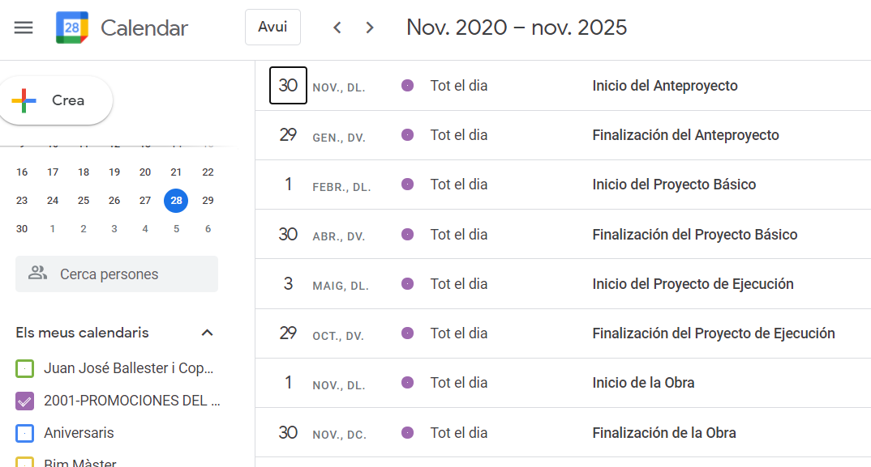

BIM system and interoperability software.
For correct interoperability between the different project agents, the following software and versions to be used are established.

BIM SYSTEM:
Discipline | Use / function | Software / tool | Version
{{SW_DISC}} | {{SW_USE}} | {{SW_TOOL}} | {{SW_VERSION}}

If any agent cannot use the specified software and version, they must inform the BIM Coordinator, who decides how to resolve it, always with the approval of the office BIM Manager.

Coding of project and control files.
Project rule generated from MC Proyectos
Native container pattern: {{STD_NATIVE_PATTERN}}
Export container pattern: {{STD_EXPORT_PATTERN}}
Control-file pattern: {{STD_CONTROL_PATTERN}}
Separator / case rule: {{STD_SEPARATOR_RULE}}
A clear and unambiguous file-naming criterion is established for the files generated throughout the project.

All the project's folders and files are sufficiently identified to be locatable on every drive declared for that project, local or in the cloud. The naming is always consistent and follows the criterion below:

FILE NUMBER
COMMON FILE CODE: 4 DIGITS
FILE CODING: (as seen in this document, we have adopted {{CODE}})

PHASE/PROJECT
Preliminary design AP
Schematic design PB
Detailed design PE
Construction supervision DO

DISCIPLINE
ARQ ARCHITECTURE
EE ARCHITECTURAL ENERGY EFFICIENCY
3D RENDERS AND VISUALISATION
STR STRUCTURE
INS MEP SERVICES (per CYPE price-generator criterion)
Sub-disciplines IA AUDIOVISUAL
IB HVAC SYSTEMS
IC HEATING, HVAC AND DHW
IE ELECTRICAL
IF PLUMBING
IG GAS
II LIGHTING
IL TELECOMMUNICATIONS
IO FIRE PROTECTION
IP LIGHTNING PROTECTION
IS DRAINAGE
IT TRANSPORT (LIFTS)
IV VENTILATION
COO CLASH COORDINATION
MM MULTIMEDIA
MP QUANTITIES AND BUDGET
SS HEALTH AND SAFETY
OCT TECHNICAL CONTROL BODY (external)
JO SITE MANAGER
EO SITE FOREMAN
JI MEP MANAGER
FM FACILITY MANAGEMENT

For example:

PHASE/PROJECT FILE
FileCode-Phase-Name-Discipline.type
{{CODE}}-PB-MODEL-ARQ.rvt
REVIT model of the ARCHITECTURE for the SCHEMATIC DESIGN of project {{PROJECT_NAME}}.

CONTROL FILE
FileCode-Name.type
{{CODE}}-CONTROL.xlsx
Data CONTROL document for project {{PROJECT_NAME}}.

EXPORT FILE
Date_FileCode-Phase-Name-Discipline-Phase.type
20-12-03_{{CODE}}-PE-EXPORT-STR.ifc
EXPORT file of the STRUCTURE in the DETAILED DESIGN phase of project {{PROJECT_NAME}}, dated 3 December 2020.

IMPORT FILE
FileCode-Phase-Name-Discipline.type
{{CODE}}-PE-IMPORTED-STR.ifc
File for linking the STRUCTURE in the DETAILED DESIGN phase of project {{PROJECT_NAME}}. These files are created from the export files (copy + paste) and renamed; note that they must NEVER contain the date in their name, to avoid losing links; they are overwritten in place within their folders. The versions of these files are the export files.

FILE IN THE 'PREVIOUS' FOLDER
Working files that must be archived because they have been shared with a project agent are saved in the PREVIOUS folder, adding the date in YY/MM/DD format.
Date_FileCode-Phase-Name-Discipline.type
20-12-09_{{CODE}}-PE-MODEL-STR.ifc
File for IFC interoperability of the STRUCTURE model in the DETAILED DESIGN phase of project {{PROJECT_NAME}}, dated 9 December 2020.

FILE IN THE 'DELIVERED' FOLDER
Published files (published means a file that has already been completed — for example when we produce a schematic design, it is stamped and delivered to the town hall, this being the final publication source of the schematic design) are saved in the DELIVERED folder, because they have been delivered as a milestone. The date in the name corresponds to the last edit and/or delivery date.
Date_FileCode-Phase-Name-Discipline.type
20-10-31_{{CODE}}-PB-MODEL-ARQ.ifc
IFC delivery file for the building-permit application of the SCHEMATIC DESIGN of project {{PROJECT_NAME}}, dated 31 October 2020.

The DELIVERED folder also contains PDF files of deliverable documents (reports, specifications, H&S study, calculations, etc.). These documents never generate a single PDF for an entire phase, to avoid overly heavy files. Their names are:
Date_FileCode-Phase-Name-Discipline.type
20-10-31_{{CODE}}-PB-REPORT-ARQ.pdf
20-10-31_{{CODE}}-PB-DRAWINGS-ARQ.pdf
20-10-31_{{CODE}}-PB-SPEC-ARQ.pdf
20-10-31_{{CODE}}-PB-PEM-SUMMARY-ARQ.pdf

21-03-05_{{CODE}}-PE-REPORT-ARQ.pdf
21-03-05_{{CODE}}-PE-REPORT-STR.pdf
21-03-05_{{CODE}}-PE-REPORT-INS.pdf
21-03-05_{{CODE}}-PE-DRAWINGS-ARQ.pdf
21-03-05_{{CODE}}-PE-DRAWINGS-STR.pdf
Etc.

GENERAL RULES:
- File and folder names must not contain special characters (“$%&/* or similar).
- Names are as short as possible while still clearly identifying their content.
- Every file that is generated and must be controlled is filed, suitably dated, in the PREVIOUS folder.
- As a general rule, all files contain the date, and versions are kept in the PREVIOUS folder inside their location folder, the live working file being the only one kept 'closest to hand'.
- Folders are created at the moment they are needed, never in advance, so they do not remain empty.
- Whenever a date is added to a folder or file, it uses the format: 'YY-MM-DD'.
- Exported files that are linked must not be moved or renamed, to avoid losing the link. If necessary, consult the project BIM Coordinator.
- The .xlsx control documents for documentation/information/versions must contain the update date and the person who updated the file (inside the file, not in its name).

Folder structure for support files: templates and libraries.
Approved project support resources. Only the version authorised for this project may be used. The office library remains the source; this register identifies the project-approved selection.
N | Resource type | Resource / file | Version | Approved location | Disciplines | Owner | Status
{{RES_N}} | {{RES_TYPE}} | {{RES_NAME}} | {{RES_VERSION}} | {{RES_LOCATION}} | {{RES_DISCIPLINES}} | {{RES_OWNER}} | {{RES_STATUS}}
For the whole office there is a folder called BIM RESOURCES, located on the server matrix, used for developing projects. Its organization is:

- 00-BIM Standards
- 01-COMMON
- Manuals and tutorials
- IES lamp photometry
- RFT Family templates
- Annotations
- Modeled elements
- Conceptual masses
- RTE Project templates
- TXT Shared parameters
- XML Navisworks search criteria
- BEP
- information production standard
- Process maps

- 02-ARCHITECTURE (ARQ)
- RTE ARQ project templates
- TXT ARQ shared parameters

- 03-BUDGETS, PLANNING AND QUANTIFICATION (MP)
- RTE Quantities project templates
- RTE Health & safety project templates
- TXT Key notes
- XLS Quantities and valuation templates
- BC3 Templates with empty WBS for quantity take-off

- 04-ENERGY DESIGN (EE)
- LEED and BREEAM guides
- WEA Weather files
- Documents
- RTE Project templates
- TXT Shared parameters

- 05-STRUCTURE (STR)
- RTE Structure project template
- XLS Schedule templates
- DOC Document templates
- TXT Shared parameters
- XML Navisworks search criteria
- TXT Key notes

- 06-MEP SERVICES (INS)
- RTE MEP project template
- XLS Schedule templates
- DOC Document templates
- TXT Shared parameters
- XML Navisworks search criteria
- TXT Key notes

- 07-IMAGES
- Environment photos
- People photos
- Texture photos
- Vegetation photos

- 08-RFA LIBRARY
- Annotations
- Title blocks
- ARQ components
- STR components
- INS components
- REV components (being created and reviewed by the BIM Manager)

- 09-MATERIALS LIBRARY
- Appearances

File (project record) folder structure
For project development we use a Common Data Environment (CDE), which is our cloud server. To access it, configurations must be set on the PC or Mac to establish an access VPN via a username/password provided by the office. These access keys grant permission to access the directories useful for each agent.
External agents only have access to specific directories of the projects they are working on. If an agent needs access to other directories, they must request it from the BIM Coordinator for authorisation.
Office staff have access to all the server information regarding projects.

Folder structure of a project:
Generated automatically for this project on “Create folders + documents” — it reflects the folders that actually exist (created by the app plus any added by hand), to 3 levels:
{{FOLDER_TREE}}

Model organization. Worksets
Project rule generated from MC Proyectos
Central model location: {{STD_CENTRAL_LOCATION}}
Workset / model-split rule: {{STD_WORKSET_RULE}}
Backup / recovery rule: {{STD_BACKUP_RULE}}

Collaborative working
In principle it will not be necessary to work with worksets, since there will be one modeler per discipline and a file will be created in each case that only that modeler will use.
If the project is large enough and it becomes necessary to divide parts of the modeling among several office colleagues working on the same discipline and model, a central file is created to carry out the work collaboratively in this respect.
It is the project BIM Coordinator who decides on the need to “share” the workload. To do so, the BIM Coordinator is responsible for creating a SINGLE CENTRAL model file for collaborative work by several team members. The BIM Coordinator also creates the worksets and coordinates the work.

Configuration and location of the central file
The central model is located in the corresponding folder within the CDE folder structure (detailed in section A.6).

Relocating the central file and backup.
The BIM Coordinator is responsible for making archived copies of the Central Working Model, as needed and as they see fit. This is done so that the file does not lose its Central Working Model property, so modelers can continue working without noticing any change; they must be notified in advance to ensure everything is synchronized.
Options: copy + paste the file into the PREVIOUS folder and rename it to indicate the date
open the file and Save As into the PREVIOUS folder with the date in the name

Worksets
The partitioning of the project into worksets is done according to the division of tasks to be carried out by each modeler. E.g.: Walls, Floors, Joinery, etc.
This is left to the BIM Coordinator's decision.

Parameter management and organization
Project rule generated from MC Proyectos
Shared-parameter file: {{STD_SHARED_PARAMETER_FILE}}
Parameter naming prefix: {{STD_PARAMETER_PREFIX}}
Criteria for managing and organizing parameters in the organization's and the project's environment.

Shared parameters
Management of these parameters is the responsibility of the office BIM Manager. As a general rule, the parameters to be used come loaded in the RTE working template.

Project parameters
If a team member needs to use a new parameter specific to the project, they request it from the BIM Coordinator, who reviews the existing parameters (of all disciplines). If the parameter already exists in another discipline with the same name and an identical or similar function, the same parameter is used for both disciplines.
If it is created and found useful for other future projects, its incorporation into the shared parameters file is requested from the office BIM Manager.

ENVIRONMENT CRITERIA
Criteria concerning the organization within the modeling-platform environment and the BIM system. Initial configurations, project mapping, organization, element identification and modeling flow. Common information-management environment and flow: texture and material libraries, databases, schedules. Model visual configuration.

User interface.
This section defines how the Revit interface must be configured so that all computers work with the same interface, so any colleague can use any computer without noticing interface changes. It also streamlines the onboarding of new members and the resolution of possible software problems/faults.

Initial Revit configuration.
The criteria to unify the working-environment interface are:
- Project browser on the left.
- Ribbon display mode as shown in the image.
- Properties palette on the right.
- Quick access toolbar as shown in the image.
- View control bar.
- Navigation bar.
- Drawing area.
- Drawing area colors. By default they are black on a white background.

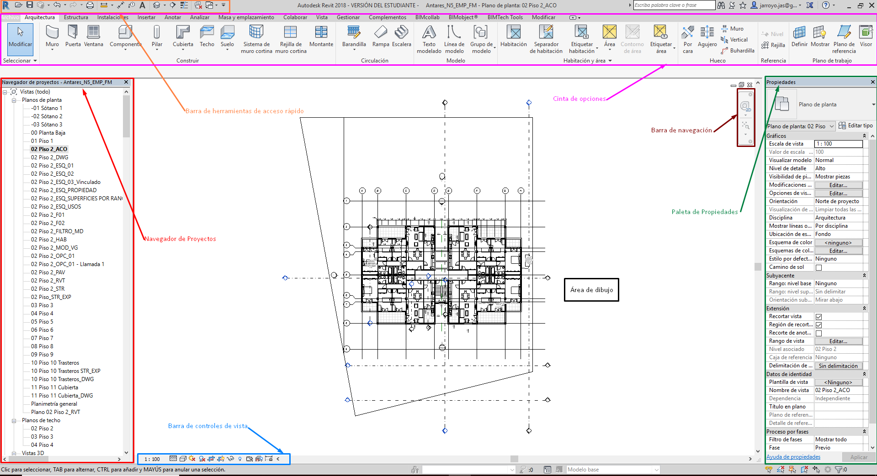

First steps
At the start of a project, the BIM Coordinator is responsible for creating the Revit file from the company's RTE template. The new RVT file is saved per section A.6 (the central file is created following the collaborative-working protocol, if the BIM Coordinator deems it necessary).
The template is in the location defined in section A.5.

Preferences and initial configuration.
This section defines Revit's preferences and initial configuration, so as to ensure they are common to all team members.

Units in Revit.
Project units:

The project units are set to METERS, as shown in the following image:
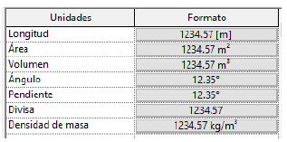

For annotation, drawing and other units, the same units in METERS are generally used, always with 3 decimals.
For dimensioning on detail drawings (joinery, furniture, MEP services, etc.), dimension units in MILLIMETERS are used with 0 decimals.

Project orientation, base point and survey point configuration:
Project base point. Coordinates and location.

The project base point is set at a fixed point of the project, specifically at the lower-left vertex of the building. In such a way that the typical floor plan of the building grows in the positive direction of the X and Y axes.
Likewise, the project base point must be easily identifiable on all the project's floors, the recommended point being the lower-left corner of the last column located at the lower-left part of the floor plan.

Coordinates: N/S 0.00000
E/W 0.00000
Elev. 0.0000
Angle to true north 0.00º (as far as possible)

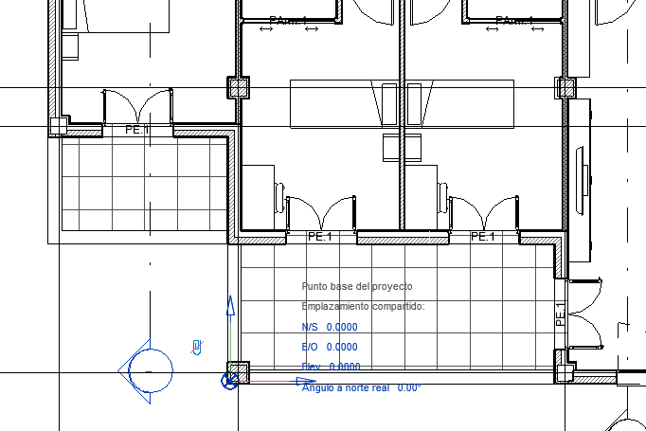

Project survey point. Coordinates and location.

The project survey point coincides with the project base point.

Coordinates: N/S 0.00000
E/W 0.00000
Elev. 0.0000

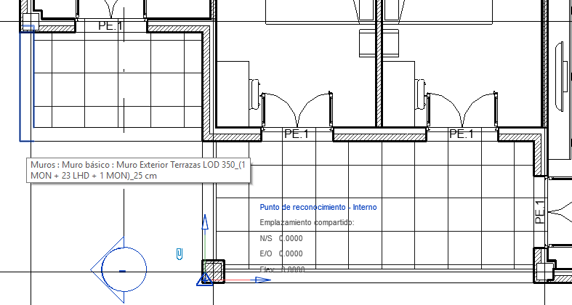

Orientation (Project North and True North).

PROJECT NORTH is based on the predominant axis of the building's geometry.
TRUE NORTH is given by the building's actual location on the plot.
If project north and true north do not coincide and there is an angular offset, work is always aligned with project north.

Coordinate protocol for interoperability.
For correct interoperability with the other BIM solutions, we always make the project base point coordinates and the Revit origin coincide. So that both the Project Survey Point and the Project base point are assigned the coordinates 0,0,0, which also coincides with the outermost lower-left vertex of the building.

Calculation units for each discipline.
In this section the calculation units to be used are defined, so that they are common to all team members.

Calculation rules
- Area and volume calculation configuration:
Room areas are given by the area value between wall finishes.
Room volumes are given by the volume value between wall finishes.
Built (gross) areas. To obtain the built areas, a schedule that calculates them is created.
Built areas are delimited by the exterior area value.

Level definition.
This section sets out the common criteria to follow for creating levels in the model.
Once the project has started and after the initial configuration, the levels must be defined, following these criteria:

Level definition criterion.

Architectural model:
- As many levels are defined as floors the project has.
- Levels are placed at the finished-floor level of each storey.
- A final level may be created for the roof parapet height.
- Each level contains its corresponding slab (below) and all the elements above it. Likewise, all model elements are referenced to their corresponding level, with or without a base offset, so that if the level's elevation changes, all elements linked to it also change by the same value.
- The level naming is: NN (a two-digit number indicating the floor order; for basements it has a negative sign in front and goes descending) [space] Basement or Floor (level name per section A.2.2), for example:
- 01 S1.
00 PB.
01 P1.
02 PC.

Structural model:
- As many levels are defined as the architectural model has.
- In this case the levels are referenced to the architectural model levels, with the negative offset corresponding to the layers above the slab (self-leveling, underfloor heating, and finish layers).
- The level naming is the same as the architectural model, adding at the end: [space] STR, to differentiate them.

View range and plan region configuration.
The following View Ranges are defined for all views:

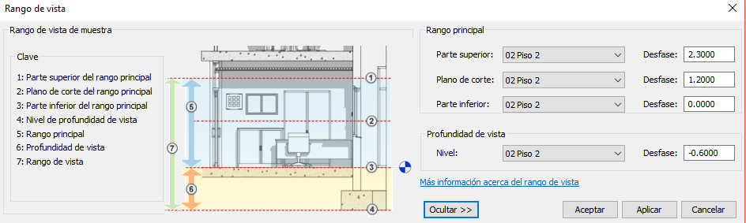

If a different view range is needed in a specific area of the drawing, a plan region is created following these criteria:
- It is always a delimited area not exceeding 20% of the floor plan. Otherwise, a new view is created.
- It is adjusted to the area of interest, avoiding interfering with the rest of the view.

Project mapping. Navigation.
We begin modeling and we need the views. All the criteria for creating them, organizing them and working with them must be established. In addition, we will need to insert or link files that serve as a reference for modeling, and we must define how to work with this kind of information external to the project.

Views. Naming. Criteria for their creation, orientation and deletion.

PLAN views are named following the criterion below:
Discipline [_] Level [_] Description

Discipline |  | _ | Level | _ | Description
ARQ  EE  EST  INS  IA  IB  IC  IE  IF  IG  II  IL  IO  IP  IS  IT  IV  COO  MM  PRE  SS  FM | Architecture  Energy Efficiency  Structure  MEP Services  Audiovisual  HVAC System  Heating, HVAC and DHW  Electrical  Plumbing  Gas  Lighting  Telecommunications  Fire Protection  Lightning Protection  Drainage  Transport (Lifts)  Ventilation  Coordination  Multimedia  Budget-Quantities  Health and Safety  Facility Management | _ | S2  S1  PB  P1  P2  .  .  .  PC | _ | Dimensioned plan

E.g.: ARQ_01_Dimensioned plan

ELEVATION views are named following the criterion below:
By default, the following are defined in the template:
ELEV_NORTH
ELEV_SOUTH
ELEV_EAST
ELEV_WEST
For elevations created for a specific use:
ELEV [_] [orientation] [_] [Description]

E.g.: ELEV_NORTH_Heights

SECTION views are named following the criterion below:
SECT [_] [2-digit creation order number] [_] [Description]

E.g.: SECT_02_Longitudinal

CEILING views are named following the criterion below:
CEIL [_] [Discipline] [_] [Level] [_] [Description]

E.g.: CEIL_INS-IE_P1_Lighting detail

3D views are named following the criterion below:
3D [_] [2-digit creation order number] [_] [Description]

E.g.: 3D_02_Stair core

View phase criteria.
As this is a new-build project, all the project views are created in the “New Construction” phase and with the “Show All” filter.
For a refurbishment project, the BIM Coordinator must create the corresponding phases: “Existing”, “Demolition” and “New Construction”, with the corresponding filters.

Project browser organization.
A correctly structured and coded view browser is essential for comfortable and efficient work by the team members. The shared parameter BROWSER-VIEW USE comes loaded in the template.
The project BIM Coordinator is responsible for managing this parameter.

Sheet browser organization. Title block. Parameters.
The Sheet Browser organization is by “Phase and Discipline”. There is a parameter to organize sheets by their type, which comes loaded in the template.
The BIM Coordinator is responsible for managing this parameter.

Schedule organization
Schedules have the following uses:
- Control
- Publication
- Quantity take-off
- Export
- Working
- Etc.
The schedules come loaded in the template and are configured according to their use. The BIM Coordinator is responsible for managing, creating and organizing them.

Procedure for linking/inserting files.
For modeling, it will be necessary to use other files within the working file; the following are defined:
- CAD files. Primitive project information, needed to start modeling.
They are INSERTED into the working file.
- Coordination/interoperability models. Files from disciplines other than the file in use.
They are LINKED into the working file.

Procedure for creating details.
Since design views for generating details in Revit are not associated with the model, Revit is not used to create details.
The office has standard details in the common library, in the resources folder; the details are defined and simply have to be adapted to the current project. These details are CAD files.
New construction details are also created in CAD from CYPE price-generator details, always with the BIM Coordinator's approval.
The incorporation of newly generated details into the common library is requested from the office BIM Manager.

Procedure for creating legend views.
The default legend views come loaded in the template.
If a new legend view needs to be created, it must follow the criteria of the loaded legend views; the scale and other parameters are appropriate to the intended use of that legend view; in any case it must be consulted with the BIM Coordinator.

View splitting procedure.
For Section views where the typical floor repeats, the view may be split so that only the typical floor and those floors different from it remain visible.

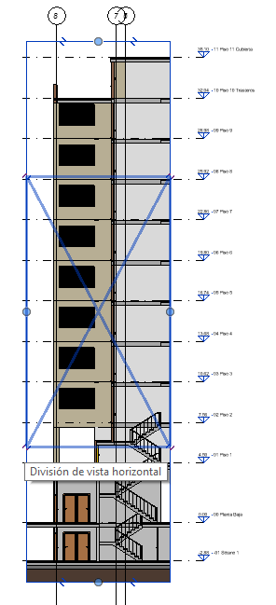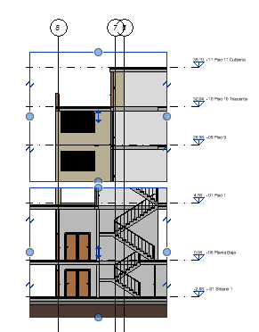

Organization of in-situ elements.
As a general rule, this information production standard does not use in-situ (in-place) elements. Modeling geometry directly in place is considered poor BIM practice: such elements cannot be reused across projects, are unreliable to quantify and schedule, increase model size and hinder coordination and clash detection, and fall outside the family-library workflow. All model components must therefore be created as loadable families (see the following section). In-place modeling is admissible only, exceptionally, for singular geometry that cannot be resolved with a loadable family — always with the prior approval of the BIM Coordinator, and never for elements that must appear in quantity take-offs.

Organization of loadable elements. Libraries.

Modeling criteria for component families:
The component families come loaded in the template. If other families are needed — obtained from the internet, created, or similar — the family's integrity must be checked before loading it into the project. To do so, check:
  - That they contain the minimum parameters necessary for the correct development of the project.
  - That the visibility and representation are adequate.
  - That the file weight is not exceeded.
  - The BIM Coordinator must approve the use of that family.
  - The BIM Manager must approve the incorporation of that family into the common library.

Criteria for creating, updating and organizing families and libraries.
For project development, the creation of new families must always be avoided; all necessary ones come loaded in the template.
If families for elements not in the template are needed, consult the previous section.

Criteria for managing elements/views not used in the project throughout its development.
At the end of each phase, the BIM Coordinator reviews the project and deletes the unused elements they consider appropriate.

Texture and material library.
When starting the modeling of a new project, it is likely that, to meet the client's requirements, new materials will need to be created. Therefore, the criteria for how to create and organize them are set out below, as well as how they must appear in the project environment, and which team member will be responsible for it.

Texture and material library. Management and organization. Responsible person.
The materials library comes loaded in the RTE template used for modeling the project. This library is created from the Autodesk template and is populated as the project requires.

The person in charge of materials and textures in the project is the visualisation lead, always under the BIM Coordinator's supervision. To complete structural, thermal and other characteriztic parameters, the visualisation lead may delegate that task to the Structure or MEP leads, as appropriate.

Criteria for generating new textures and materials. Responsible person.
The person in charge of creating new materials and textures for a specific project is the visualisation lead. If the new textures are to be incorporated into the office library and updated in the template, this must be requested from the BIM Coordinator, who does so with the office BIM Manager's approval.
The naming of the BIM model's textures and materials is established according to the eCOB standard, which defines the following:

A BIM material name must be unique and is expressed in the form:
EXAMPLE (the hyphen [ - ] is used as the separator)
OrderCode | BIMMaterialName | MaterialForm | *(MaterialProduct)
with the meaning and content set out in the following table:
FIELD | CONTENT | NOTE | EXAMPLE
OrderCode | Code to order the materials within a library of the modeling platform | In many cases it is useful to equate BIM materials to construction work items, including their code fully or partially | E652
BIMMaterialName | Name of the BIM material. | It is advisable to abstract the real construction materials that the BIM material must represent. For example: ceramic masonry instead of ceramic pieces and mortar, reinforced concrete instead of concrete and rebar, etc. | PlasterboardSheet
MaterialForm | Physical format the BIM material takes when installed on site. | Due to modeling-tool limitations, the geometry of the BIM material may not match the physical limits of the construction products. For example: a tiling layer with a defined thickness but without joints; a thermal insulation layer is represented the same whether supplied as a board or a roll. It is therefore advisable to include the form in the BIM material name. | Sheet  Board  Roll
*MaterialProduct | * Optional field.  Name of the commercial product that generates the BIM material. | Applies to commercial products. Not used in generic BIM materials. | Name
Below, several examples of applying this naming:
EXAMPLE OF A GENERIC BIM MATERIAL (the hyphen [ - ] is used as the separator)
E652 | PlasterboardSheet | Board

EXAMPLE OF A COMMERCIAL BIM MATERIAL (the hyphen [ - ] is used as the separator)
E652 | PlasterboardSheet | Board | ProductName

Reference price and materials database.
Once the BIM requirements are known, all project agents have access to a common price and materials database.

Price and materials database. Management and organization. Responsible person.
The price and materials database to be used is the Arquímedes price generator. The person in charge is the budget lead, always under the BIM Coordinator's supervision.

Criteria for generating new materials and prices. Responsible person.
To create new materials, the following naming is used:

the three letters of the price generator, followed by an underscore, and including the following information: size, model, etc.

For its inclusion in the materials library folder and incorporation into the template, this must be requested from the BIM Coordinator, who carries out this task with the office BIM Manager's approval.

Model visual configuration.
When starting and during modeling, we will need to configure it visually. A modeler may need to create — for example, to make a sketch — a new line type not in the template, or a new view template or selection filter to help in their work. These elements must be created and named following a common criterion.
This section defines aspects such as Object Styles (by default those defined in the template), the project's View Templates and which views they apply to, as well as the criteria for creating new view templates, new line styles, new line patterns and new fill patterns (work environment), the criteria for the visual configuration of new selection filters, of worksets, etc.

Line styles, line patterns, fill patterns. Criteria for managing styles, weights and patterns.
The line styles, line patterns, fill patterns and line weights are defined in the line-styles template.

The person in charge of creating new line styles, line patterns or fill patterns for a specific project is the visualisation lead. Before incorporating it into the existing styles, it is supervised by the BIM Coordinator.

Line styles. The following categories are used for each line:

Lines | Projection line
Wide lines | Section-phase line
Insulation line | Insulation line
Hidden lines | Hidden projection line

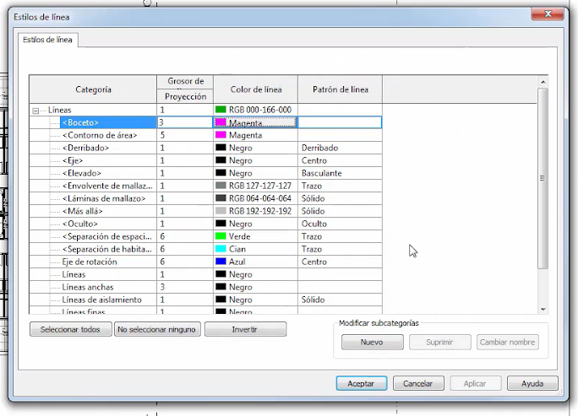

Line weights. Line weights are defined in the corresponding table.

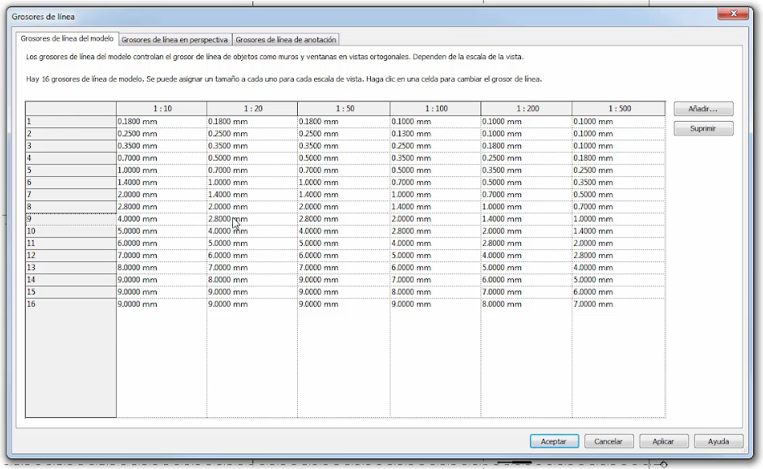

Line patterns. The following criteria are used for creating new line patterns:
- the naming is: number 0 + underscore + type initial (Dash, Dot or Space) followed by the numeric value in mm.
- E.g.: 0_T6_E4.5_P_E4.5. (6mm Dash + 4.5mm Space + Dot + 4.5mm Space)

Fill patterns. The following criteria are used for creating new fill patterns:
- The orientation in host layers is “orient to view”.
- the naming is: number 0 + underscore + what it represents (E.g.: 0_Terrazzo)

Dimensions, texts, tags, symbols.
Dimension types. To create a new dimension type, an existing one is duplicated.
The type name follows this criterion:

[Name of the base style] [_] [Purpose/use]
Example: Linear dimension_site works

Its creation is carried out by the visualisation lead with the authorisation of the project BIM Coordinator.
The following dimension types are defined in the template used for the project:

Linear dimension style
Chain type | Continuous
Leader type | Arc
Tick mark | Diagonal
Line weight | 1
Tick mark line weight | 3
Dimension line extension | 0.00 mm
Gap between witness line and element | 1.50 mm
Witness line extension | 2.40 mm
Axis pattern | Knocked down
Color | Black
Width factor | 1.00
Text size | 2.10 mm
Text offset | 0.10 mm
Font | Arial
Text background | Opaque
Unit format | meters

Angular dimension style
Leader type | Arc
Tick mark | Diagonal
Line weight | 1
Tick mark line weight | 5
Dimension line extension | 0.00 mm
Gap between witness line and element | 1.50 mm
Witness line extension | 2.40 mm
Axis pattern | Solid
Color | Black
Width factor | 1.00
Text size | 2.40 mm
Text offset | 1.50 mm
Font | Arial
Text background | Opaque
Unit format | meters

Radial dimension style
Leader type | Arc
Tick mark | 30 degrees Arrow
Line weight | 1
Tick mark line weight | 5
Dimension line extension | 0.00 mm
Flipped dimension line extension | 0.00 mm
Color | Black
Width factor | 1.00
Text size | 2.40 mm
Text offset | 1.50 mm
Font | Arial
Text background | Opaque
Unit format | meters
Center tick mark size | 3.20 mm

Diametric dimension style
Leader type | Arc
Tick mark | 15 degrees Arrow
Line weight | 1
Tick mark line weight | 1
Dimension line extension | 2.50 mm
Flipped dimension line extension | 2.50 mm
Color | Black
Width factor | 1.00
Text size | 2.50 mm
Text offset | 1.50 mm
Font | Arial
Text background | Opaque
Unit format | meters
Center tick mark size | 3.20 mm

Elevation dimension style
Arrowhead leader | 20-degree filled arrow
Leader line weight | 1
Leader arrowhead weight | 1
Color | Black
Symbol | M_Elevation dimension – Filled target
Width factor | 1.00
Text size | 2.40 mm
Text offset | 1.50 mm
Font | Arial
Text background | Opaque
Unit format | meters
Text offset from symbol | 6.35 mm
Text orientation | Horizontal
Text location | Above leader
Elevation indicator | EL
Elevation origin | Project base point

Point coordinate dimension style
Arrowhead leader | 20-degree filled arrow
Leader line weight | 1
Leader arrowhead weight | 1
Color | Black
Symbol | M_Elevation dimension – Filled target
Width factor | 1.00
Text size | 2.40 mm
Text offset | 1.50 mm
Font | Arial
Text background | Opaque
Unit format | meters
Text offset from symbol | 6.35 mm
Text orientation | Horizontal
Text location | Above leader
Elevation indicator | EL
Coordinate origin | Survey point

Slope dimension style
Arrowhead leader | 30-degree filled arrow
Leader line weight | 1
Leader arrowhead weight | 1
Color | Black
Slope direction | Down
Leader line length | 25.00 mm
Width factor | 1.00
Text size | 2.40 mm
Text offset | 1.50 mm
Font | Arial
Text background | Opaque

Text types. Their creation is carried out by the visualisation lead under the BIM Coordinator's supervision.

For creating new texts, the criteria in the following table are taken into account:

Text height (mm) | Line weight | Use
1.8 | 2 | General texts, dimensions, notes. A3-A4 formats
2.5 | 3 | General texts, dimensions, notes
3.5 | 4 | Headers
3.5 | 5 | General texts, dimensions, notes. A1-A2 formats
5.0 | 7 | Secondary titles
7.0 | 8 | Main titles

Tags. New tags are created from multi-category tags.

The parameters of the new tags are:
family name / type name / type mark / comments
Its creation is carried out by the visualisation lead with the BIM Coordinator's authorisation.

General project visibility options: Object Styles.
The Object Styles configuration can only be modified by the Project Coordinator.

General view visibility options. View template application criteria.

To control view visibility, view templates are preferably used.

Depending on the use, the following view templates are used:

View template | View type
0 Modeling | Modeling views
1 Publication | Views placed on sheets for publication
2 Export | Views prepared for export to other disciplines

If the view use is that of working by any team member, the following view templates are used, depending on the type of representation it contains:

View template (working) | View type
P Plans | Plan views
A Elevations | Elevation and section views
3D | 3D views

Modifications to the configuration of view templates for view uses 0, 1 and 2 can only be made by the Project Coordinator.

The naming of the view templates for uses 0, 1 and 2 of the previous table follows this criterion:
[Discipline Code]_[View Family]_[View-use numeric code]_[View content] [space] [Scale]
Example: ARQ_PL1_Uses 1:100 (Architecture view template assigned to a publication view (1) containing the layout by uses, at scale 1:100)

Per-view visibility control. Visibility/graphics overrides

Per-view visibility control is defined in the view templates. The person in charge of modifying this configuration is the visualisation lead. Before incorporating it, it is supervised by the BIM Coordinator.

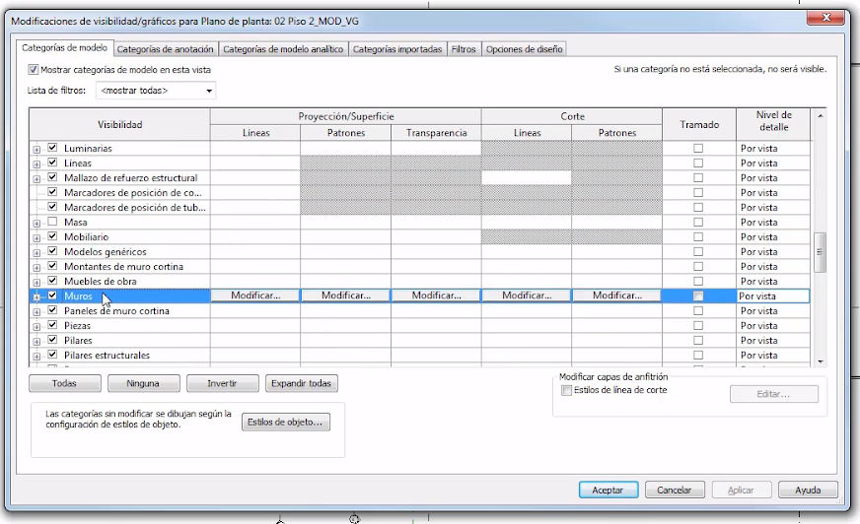

Per-element visibility control.

Graphic overrides of an element per view are avoided, since it later becomes very difficult to track changes to those elements.

Criteria for the visual configuration of worksets.

The visual configuration of the worksets is established as follows:

Levels and grids | Visible in all views
Separate buildings | Visible in all views
Circulation core / Building skin | Visible in all views
Architecture / Structure | Visible in all views
MEP (Separate worksets for each discipline) | for a specific view, its visibility is enabled from the VG dialog
One workset per linked RVT file | for a specific view, its visibility is enabled from the VG dialog
One workset for external CAD links. | Visible in all views

Modification of these criteria is the responsibility of the visualisation lead, under the BIM Coordinator's supervision.

Visualisation configuration of areas, zones and spaces.
To perform area calculations — both usable areas per room and by use, fire sectors and others — it is established that this is done by creating Rooms. From the created Rooms, color schemes are generated from which the information is extracted, following the criteria defined below:

Rooms.

They are a tool that provides very valuable information for quantities, area calculation, compliance with fire-safety and habitability regulations, and other types of analysis.
Rooms are created in a view created from the working plan view, which must be renamed with the same name as the main view, adding _ROOM.

Room criteria:
- Level constraints: rooms are always defined by their construction boundaries, except where virtual boundaries are added. To do so, always subtract the room's upper slab plus the false-ceiling space, so that the room volume is usable. This way, usable-area schedules (schematic design) and usable-volume schedules (technical building code) can be generated.

- Room number: room numbering follows the criterion defined by the developer. If there is none, the criterion is to number the rooms in ascending order as you enter the dwelling, e.g.:
1. Entrance hall,
2. Kitchen,
3. Living room,
4. Guest toilet,
5. Dining room,
6. Bedroom 3,
7. Bedroom 2,
8. Bathroom 2,
9. Main bedroom,
10. Dressing room,
11. Main bathroom.
12. Terrace 1.
13. Terrace 2.
14. Service shaft.

- Room name: names are assigned defining the space in question (as per the previous examples). Note: for bedrooms, the MAIN characteriztic is assigned to the bedroom considered largest and, for the dwelling's layout, the most important; it is always considered bedroom 1; the remaining bedrooms have ascending numbering as they move away from the main one (as per the previous examples); the same criterion applies to bathrooms.

- Associate image: images are never associated with the room, to avoid overloading the file.

- Occupancy: the space USE is indicated, per technical code DB-SI (Residential, Storage, Commercial, etc.). The office's most recurrent occupancy names come loaded in the RTE template.

- Department: for a multi-family building project, the dwelling type is indicated per the building's general layout (dwelling A, dwelling B, etc.); for a detached single-family dwelling, Dwelling is assigned whenever the use is Residential; if the occupancy indication changes, for example Administrative, another is assigned, for example Offices. The office's most recurrent department names come loaded in the template.

Color schemes.

The RTE template used for modeling the project has defined color schemes loaded, based on the created rooms.
- Color scheme by room name.
- Color scheme by use zones (day zone, night zone, etc.).
- Color scheme by property (for multi-family buildings).
- Color scheme by areas (useful for seeing at a glance whether we meet the minimum areas required by habitability and design regulations).

If it is essential to create new color schemes, the project BIM Coordinator is always consulted. Likewise, the following minimums are taken into account for the new color scheme:
- Place it in a different plan view (duplicated and renamed).
- Apply the view properties template for color schemes that comes loaded in the RTE modeling template.
- The scheme name responds to the color classification made.
- The new view name follows the same criterion as the color-scheme views in the template: [SAME VIEW NAME] _ SCH _ [COLOR SCHEME NAME].
The color scheme view has its corresponding legend incorporated.

Schedules.
This section defines the criteria for handling the model information through schedules, for creating new schedules (working schedules), for information management (schedules to be placed on sheets), and for managing model changes using schedules (for example, replacing types in more advanced modeling phases).

Criteria for managing schedules throughout each development phase.

Schematic Design phase: at the end of it, conversion of generic type marks to specific ones for joinery, MEP, etc. using schedules.

Detailed Design phase: validation of the survey/installation of the elements contained in the schedules and updating of possible last-minute construction changes (whether by removal, conversion or addition of models of washbasins, windows, etc.).

Construction Supervision phase, for As-built preparation: ratification of the information contained in the latest version of the detailed design, and planning of maintenance plans using schedules; periodicity, maintenance type, action and personnel.

Criteria for creating new schedules (working).

It must be borne in mind that schedules are focused on professional practice and that this is a LIVE project, so it is understood that the uses will vary and the information the schedules must collect will also be modulated to the needs of the moment.

General considerations:

- Definition of the use it will be intended for.
- Parameters needed to delimit its full scope.

Schedule creation criteria:
The minimum data to be contained in the schedules is listed below, according to the phase the project is in.

- Schematic Design phase:
  - ID.
  - Element type (e.g.: washbasin/toilet; interior door/exterior balcony door).
  - Dimensions (wxh).
  - Price.
  - Number of units.
  - Amount.

- Detailed Design phase:
Ratification of the schedules planned in the Schematic Design phase and, if necessary, updating them.

- During the Construction Supervision phase, maintenance preparation:
Order the concepts (columns) according to the temporal sequence of the work in the maintenance phase:
For example, for gas installation inspections with a single subcontractor:
        - Frequency
        - Property ID
        - Contact person
        - Visit scheduling date
        - Feedback from it
        - Schedule next inspection

Note that for schedules on sheets, the criteria of the APPEARANCE tab must be set, within Schedule Properties as per the attached capture, because that tab is the one that affects the schedule when it is embedded on a sheet.
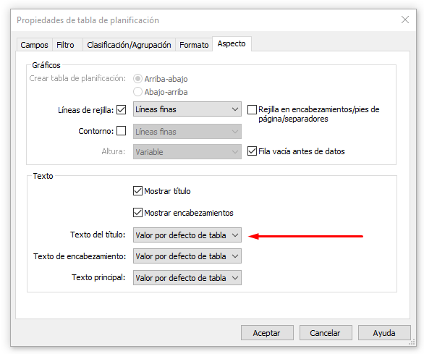
In addition, to configure the schedule's appearance on the sheets, it is also important that:
- The column width can be adjusted manually.
- The row height cannot be adjusted. It depends only on the text size.
- There are some additional graphic options for headers and columns in the schedule modification tools.
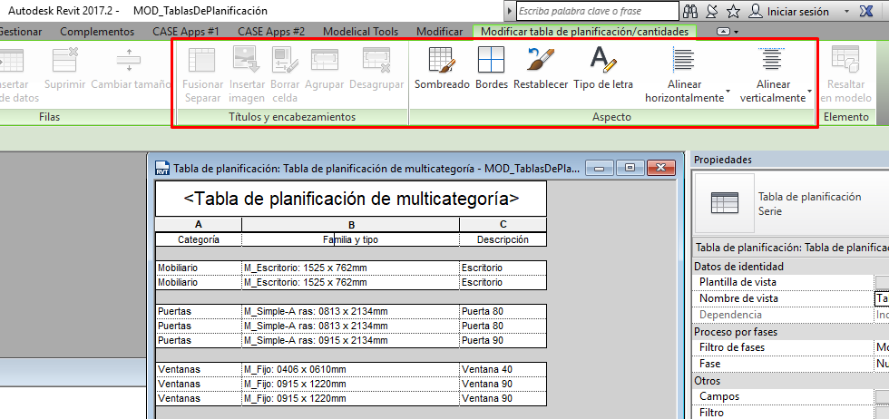

Design options.

Criteria for creating and organizing design options.
A new view is generated, naming the level _ OPT, in which the changes of the different design options are seen.
To create the different design options, first the Option Set is created, specifying what the option relates to. E.g.: “Bedroom Furniture”, “Joinery”, etc.

The naming of the created option is as follows: [OP] + [ _ ] + [consecutive number] + [ _ ] + [brief description of the option]
e.g.: OP_1_Double bed

Schedules are used to collect the potential design options.
1st column: Naming: sequential numbering: OP_1; OP_2; OP_3…
2nd column: Title: Suite + 2 Single Bedrooms
3rd column: Brief description of the proposal: OP_1 with 1 single bedroom + dressing room
4th column: Date presented to the Client
5th column: Feedback and definition of next steps (if these require new milestones, add a column with a new scheduled date).

FUNCTIONAL CRITERIA.

Concerning operational decisions related to optimal collaborative workflow. This block sets out the operational, modeling and data-management criteria to collaboratively and efficiently meet the requirements set by the client regarding geometric definition, alphanumeric information and project-linked information at each stage of its development. This promotes the team's operation based on a common methodology and language that facilitates interoperability and coordination between its members. The BEP will define the process maps and document/information exchanges in accordance with the definitions established in this block.

Model levels of development.
The levels of development define the modeling scope, i.e. the degree of detail of systems and construction elements, the data incorporated, and the definition of parameters and information linked to the elements.

Modeling scope. Model definition levels.
The modeling scope depends on the model's BIM uses and is defined in the BEP for each element/system at each project phase.

In general, the modeling scope is defined according to the project phase we are in:

PROJECT PHASE | CONCEPTUAL DEFINITION LEVEL | LEVEL OF DEVELOPMENT
SKETCH PHASE | Generic modeling | LOD 100
PRELIMINARY DESIGN | Basic modeling of the different systems | LOD 200
SCHEMATIC DESIGN | Advanced modeling of the different systems | LOD 300
DETAILED DESIGN | Advanced modeling of the different systems and specification of other generic characteriztics | LOD 350
CONSTRUCTION | Advanced modeling of the different systems and specification of specific characteriztics (manufacturers, etc.) | LOD 400
AS BUILT | Advanced modeling of the different systems and specification of final construction characteriztics | LOD 400

LOD definition
The definition of the model's geometric and information level of development in this section is the one reflected in the BEP.
Legacy LOD convention and ISO 7817-1 information need
LOD comes from the American standard (AIA). ISO 19650 does not use numbers — to avoid demanding unnecessary information simply for “moving up a level” — so the equivalent concept is the LOIN (Level of Information Need), established through delivery milestones and life-cycle objectives:
LOD (traditional) | LOD concept (AIA) | Information need context | Project information requirement
LOD 100 | Conceptual / schematic design | Conceptual model information | Generic or volumetric geometry for spatial and site analysis. Basic performance data or project objectives.
LOD 200 | Preliminary design / development | Approximate system information | Elements modeled as generic systems with approximate quantities, sizes and locations. Data for preliminary cost estimates.
LOD 300 | Detailed design / tender | Defined system information | Precise geometry in size, shape and location for 3D coordination (clash detection). Technical data ready for contracting/tender.
LOD 350 | Interdisciplinary coordination | Coordination & interface information | Geometric detail including the connections, supports and interfaces between different disciplines and construction systems.
LOD 400 | Fabrication & assembly | Information for fabrication & installation | Detailed elements with millimetric precision, ready for the workshop (direct fabrication). Assembly, sequencing and installation data.
LOD 500 | As-Built | Asset Information Model (AIM) | Verified geometry as built on site. Very high density of alphanumeric information for Operation & Maintenance (FM).
Where LOD 100–500 is referenced in this information production standard, it is used as a familiar shorthand; the governing requirement is the corresponding Level of Information Need (LOIN) per ISO 19650 — see the equivalence table above — specified by purpose and milestone, never demanding more information than needed.

LOD 100
The element may be graphically represented in the model with a symbol or other generic representation, but does not satisfy the requirements for LOD 200. Non-graphic information may be attached to the element.
BIMForum interpretation: LOD 100 elements are not geometric representations. They show the existence of a component but not its precise shape, size or location. Any information derived from LOD 100 elements must be considered approximate.

LOD 200
The model element is graphically represented within the model as a generic system, object or assembly with an approximation of its size, shape, location and orientation. Non-graphic information may also be attached to the model element.
BIMForum interpretation: at this LOD, elements are generic placeholders. They may be recognizable as the components they represent, or they may be volumes for space reservation. Any information derived from LOD 200 elements must be considered approximate.

LOD 300
The model element is graphically represented as a specific system, object or assembly in terms of quantity, size, shape, location and orientation. Non-graphic information may also be attached to the element.
BIMForum interpretation: the quantity, size, shape, location and orientation of the element can be measured directly from it. The project origin has been defined and the
Location is precise with respect to that origin.

LOD 350
The model element is graphically represented as a specific system, object or assembly in terms of quantity, size, shape, location, orientation, and its relationship/connection with other elements or construction systems is defined. Non-graphic information may also be attached to the Model.
BIMForum interpretation: the parts necessary for the coordination and interrelation of the element with nearby or adjoining elements are modeled. It will include elements such as supports and connections. The quantity, size, shape, location and orientation of the element can be measured directly from the model without reference to non-modeled information, such as notes or dimension callouts.

LOD 400
The model element is graphically represented within the model as a specific system, object or assembly in terms of size, shape, location, quantity and orientation with details and with fabrication, assembly and installation information. Non-graphic information may also be linked to the element.
BIMForum interpretation: a LOD 400 element is modeled with sufficient detail and accuracy for fabrication. The quantity, size, shape, location and orientation of the element can be measured directly from the model without reference to non-modeled information, such as notes or dimension callouts.

Protocol for defining work items and for extracting quantities and budgets.
A general protocol is established for defining work items and extracting quantities and budget.

The person responsible is the budget lead, under the BIM Coordinator's supervision.

The general work process is as follows:
- Create in Arquímedes the WBS (work breakdown structure) that the budget will have. (fig.1)
- Create the necessary lump-sum items/items with breakdown.
- From the REVIT schedules, a list of the different model elements is made in Word.
- From each list of elements, the following are extracted:
  - Work items corresponding to the model's construction elements.
  - Non-modeled work items.
- Work items to be located in the price generator.
- Copy the items by importing them from the price generator.
- Check the consistency between modeled information and budget information.

Fig. 1: WBS
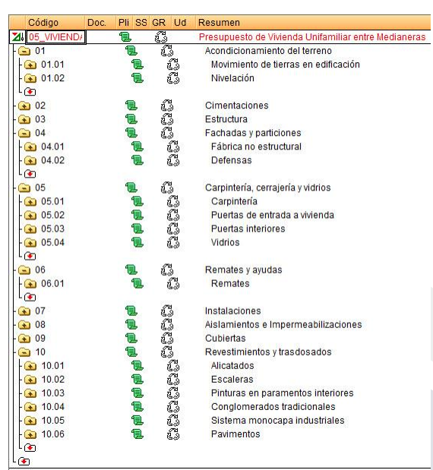

Criteria for creating/importing new items/prices not existing in the Arquímedes price-generator database.
- The creation of lump-sum items without breakdown is avoided as far as possible.
- If a new lump-sum item or a new material is created, the naming of its codes follows the criterion of the Arquímedes price-generator database.

General procedure for extracting quantities in the early project phase

The general procedure for extracting quantities in the early project phase is the CYPE budget generator.

General procedure for generating quantities in the advanced project phase
Once the model advances and the materials and construction systems are defined, more detailed quantities and budget can be obtained, based on the constructive and system characteriztics and solutions.
Each discipline provides the budget for its part, so how to include these budgets is defined.

The general procedure for extracting quantities in the advanced project phase is as follows:
- Budget creation in Arquímedes.
The WBS (work breakdown structure and the work items) is generated
- The key-notes file (.txt) for REVIT is generated and assigned to the model elements in REVIT, so that each measurement code corresponds to a key-note value.
- Assignment of items from REVIT based on the key notes. Whenever possible, schedules are used to optimize this process.
- Assignment of items that remain without a key note, and review of the change management produced.
- The item measurement criteria are checked.
- Generate the key-notes legend.
- Extract the quantities.

To add the specific budget of the other disciplines to the general budget, it is done as follows:
- Check that the cost configuration of both budgets is the same.
- Perform the budget consolidation in Arquímedes with the “Include another budget” option, and the budget of the specific discipline concerned is included.
- In the “Included budgets” option, check that the checkbox “update” is enabled, to ensure that changes made in the other disciplines' budgets are updated in the general budget.

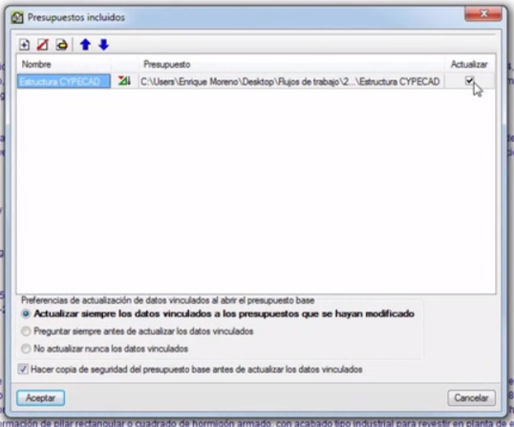

Measurement criteria: From Revit categories to Arquímedes items.

The project measurement criteria are defined:

Structure
COLUMNS
Volume measured according to Project drawings.

BEAMS
Volume measured according to Project drawings.

STRUCTURAL SLABS AND RC FLOOR SLABS
Area measured in true magnitude from the outer faces of the perimeter edge beams, according to Project drawings, deducting openings larger than 6 m².

STAIR SLAB
Area measured by its underside in true magnitude, according to Project drawings.

FORMWORK
Formwork area in contact with the concrete, measured according to Project drawings.
Architecture
FAÇADES
Area measured according to Project drawings, without duplicating corners or junctions, deducting openings larger than 4 m². In openings that are not deducted, the work of forming the interior surface of the opening is included.

PARTY WALLS
Area measured according to Project drawings, without duplicating corners or junctions, deducting openings larger than 4 m².

INTERIOR PARTITION
Area measured according to Project drawings, without duplicating corners or junctions, deducting openings larger than 4 m².

PARAPETS
Length measured to axes, according to Project drawings.

PLOT FENCING
Length measured according to Project drawings, deducting the length of door and gate openings.

JOINERY
Number of units foreseen, according to Project drawings.

GLAZING
Area of joinery to be glazed, according to Project drawings, including in each glazed leaf the frame dimensions.

FLASHINGS AND ANCILLARIES. COPINGS.
Length measured to axes, according to Project drawings.

FLASHINGS AND ANCILLARIES. SILLS.
Length of the opening width, measured according to Project drawings, increased by 5 cm on each side.

THERMAL INSULATION AND WATERPROOFING
Area measured according to Project drawings.

FLAT ROOF
Area measured in horizontal projection, according to Project drawings, from the inner faces of the parapets or perimeter upstands that delimit it.

FINISHES
TILING
Area measured according to Project drawings, deducting openings larger than 3 m². The measurement is not increased for breakage and cuts, since 5% extra pieces have been considered in the breakdown.

PLASTER RENDERING
Area measured from the floor to the ceiling, according to Project drawings, without deducting openings smaller than 4 m² and deducting, in openings larger than 4 m², the excess over 4 m². Vertical surfaces with built-in wardrobes are not subject to deduction, whatever their dimension.

EXTERIOR WALL CLADDING
Area measured according to Project drawings, deducting openings larger than 3 m² and including the development of the reveals.

SKIRTINGS
Length measured according to Project drawings, not including door openings.

PORCELAIN STONEWARE FLOORING
Area measured according to Project drawings, deducting openings larger than 3 m². The measurement is not increased for breakage and cuts, since 5% extra pieces have been considered in the breakdown.

LAMINATE FLOORING
Usable area, measured according to Project drawings. The measurement is not increased for breakage and cuts, since 5% extra pieces have been considered in the breakdown.

EXTERIOR PAVING
Area measured in horizontal projection, according to Project drawings. Trimming is not taken into account as a factor to increase the measurement, since the general percentage of breakage has been considered in the breakdown.

Modeling criteria for Non-Structural elements and Identifiers.

In general, some modeling rules are established based on the Construction Project. As far as possible, it is modeled as it is built.

This section establishes the modeling criteria for non-structural elements: architectural walls, doors, windows, furniture, architectural columns, roofs, ceilings, architectural floors, curtain walls, stairs, ramps and railings, as well as the criteria for consolidating the naming of type names and type marks in the different design phases.

Modeling criteria.
General modeling criteria are defined and then the modeling criteria for each of the Non-Structural elements are specified.

General
- All disciplines use a modeling method where the model is divided by floor levels (stories) and all model elements belong to the correct level. (ref. uBIM 01.1.4.6)
- In the architectural model, each storey contains its slab and everything above it. (ref uBIM 01.1.4.6)
- The Levels of Development (LOD) applied are those defined in the document “Level of Development Specification. Version 2016”, developed by BIMForum.

Architectural Walls
- Walls are modeled in height (upwards) and not in depth (downwards), from the level at which we create them.
- Walls are modeled at LOD 200 in the Schematic Design phase and LOD 350 in the Detailed Design phase.

Doors
- Doors are modeled at LOD 350, both in the SD phase and in the DD phase.

Windows
- Windows are modeled at LOD 350.

Furniture
- Furniture is modeled at LOD 350.

Architectural columns
- Architectural columns follow the same modeling criteria as structural columns (section C.4.1), since they are nothing more than their cladding.
- In modeling, they are placed on top of each structural column and, to create clean joints between elements, their geometries are joined.

Architectural floors
- Flooring is modeled separately from the structural slabs.
- Likewise, the flooring of each zone is modeled separately.
- The finished floor has the same elevation as each storey's level.
- Flooring is modeled at LOD 200 in the SD phase and LOD 350 in the DD phase.

Roofs
- The finished flat roof has the same elevation as the corresponding storey's level.
- Since the roof “grows” upwards, it is given a negative offset corresponding to its thickness.
- Roofs are modeled at LOD 200 in the SD phase and LOD 350 in the DD phase.

Ceilings
- The clear height with a suspended ceiling installed in dwellings is, as a minimum, that determined by the CTE (Spanish Building Code) for each room.
- Suspended ceilings are modeled at LOD 200 in the SD phase and LOD 350 in the DD phase.

Stairs
- Stairs with equal flights are modeled as a single element across all the floors they span.
- Stairs are modeled at LOD 200 in the SD phase and LOD 350 in the DD phase.

Ramps
- Ramps are modeled at LOD 200 in the SD phase and LOD 350 in the DD phase.

Railings
- Railings are modeled at LOD 350.

Naming consolidation: Type Name and Type Mark.
This section refers to the naming of Families, Type Names and Type Marks, and explains the procedure for consolidating the types of non-structural elements when we change project phase (schematic design, detailed design, construction supervision) in the model.

Type consolidation is carried out using the schedules included in the project, which come from the template it is based on, according to the criteria in section B.12.

For consolidating the naming, Type Name and Type Mark, of non-structural elements, the coding criteria specified in the table in section C.8.1 are followed.

As an example of consolidation using a schedule:

Schedule in the schematic design phase (SD):
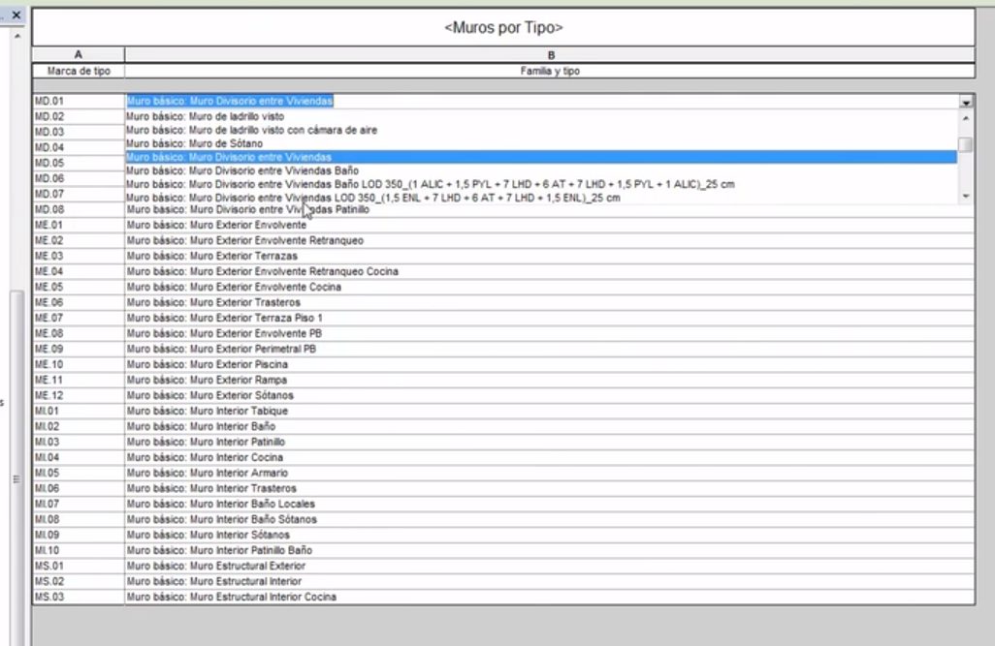

Schedule in the detailed design phase (DD):
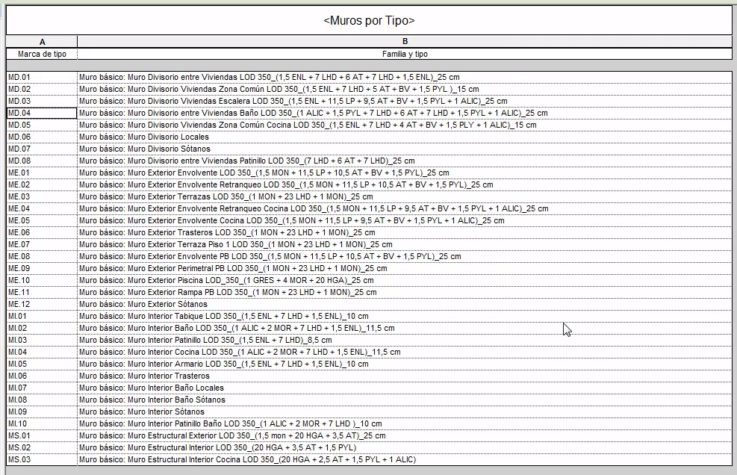

Modeling criteria for Structural elements and identifiers.
This section establishes the modeling criteria for the structural elements modeled in the Architectural Model.
The remaining structural elements are modeled in a Structural Model and according to the criteria established by the team responsible for it.

Modeling criteria.
General modeling criteria are defined and then the modeling criteria for each element are specified.

General
- Modeling must begin by studying the symmetries and general geometric relationships between the different parts of the building.
- Next, the main structural and façade alignments must be located, following the symmetries and then the clearly expressed dimensions.
- The next step is always to locate the columns on the alignments and axis intersections, or failing that, positioned relative to them by dimensions.
- Then, the architectural walls and slab openings are placed in relation to the columns (aligned to face, to axis, with a certain offset…) of the level in question, respecting the load-transfer principles.
- The logical relationship between elements of different levels is respected, whenever it makes sense.
- Next is to delimit the slabs, using as reference the elements located in the previous points, provided there are no explicit references with well-defined dimensions or offsets.
- Only as a last resort, when there is no clear reference or dimension delimiting it, may an element be located from the measurement taken directly on a CAD file or by selecting elements on imported files.

Structural columns
- Columns are modeled at LOD 350.
- The column is identified the same on all floors, and is modeled by floors.

Slabs
- The slab has a negative offset equal to the flooring thickness (plus the layers preceding it, such as self-leveling, underfloor heating, or others) with respect to the elevation associated with each storey's level.
- They are modeled at LOD 200 in the SD phase and LOD 350 in the DD phase.

Table of structural elements and their ID in each project phase.
As in section C.3.2., type consolidation is carried out using the schedules included in the project, which come from the template it is based on, according to the criteria in section B.12.

For consolidating the naming, Type Name and Type Mark, the coding criteria specified in the table in section C.8.1 are followed.

Modeling criteria for MEP elements and Identifiers.

In this section it must be borne in mind that in the Architectural Model we will use component families; the MEP services are not modeled here — the specializt will carry them out with their specific tool — so what is defined here are the criteria for using those loadable MEP element families.

This section establishes the modeling criteria for the MEP elements modeled in the Architectural Model.
The remaining MEP elements are modeled in an MEP Model and according to the criteria established by the team responsible for it.

Modeling criteria.
The criteria for using the loadable MEP element families are defined.

- The MEP elements are loaded in the RTE template.
- If new MEP components need to be loaded, they are available in the MEP elements library located in its corresponding folder as indicated in section A.5.
- Newly created MEP elements are modeled at LOD 350.

Table of MEP elements and their ID in each project phase.
As in section C.3.2., type consolidation is carried out using the schedules included in the project, which come from the template it is based on, according to the criteria in section B.12.

For consolidating the naming, Type Name and Type Mark, the coding criteria specified in the table in section C.8.1 are followed.

Area modeling criteria.

An area is a subdivision of the space of a construction model, containing one or more rooms (see section C.7). Areas are used to analyze the model in different ways, based on usable or built areas.
This section establishes the modeling criteria for the areas placed in the Architectural Model.

Modeling criteria.

Areas | Modeling criteria

We use area plans to see the gross built area, i.e. the boundaries are around the exterior of the building.
The area plan is made from the modeling plan.
Boundaries and areas are created per dwelling, to use them in the (built) area schedule.
For managing the areas, there is a schedule loaded in the template.
When you want to delete an area, it must be done from the schedule.

Table with Functional elements and their ID in each project phase.

The consolidation of the area parameters is carried out using the schedules included in the project, which come from the template it is based on, according to the criteria in section B.12.
For the naming, Number and Name, of the rooms, the coding criteria specified in the table in section C.8.1 are followed.

Room modeling criteria.

Rooms are subdivisions of the construction model's space, based on walls, floors, roofs and ceilings and/or room-bounding elements. These room-bounding elements are used as a reference for calculating the room's perimeter, area and volume. This section establishes the modeling criteria for the rooms placed in the Architectural Model.

Modeling criteria.

Rooms | Modeling criteria

Wardrobe walls are not room boundaries, so in bedrooms the room also counts the wardrobes.
The rest of the interior perimeter is defined by its room boundaries.
Every enclosed space larger than 0.25 m² forms a room.
They must be modeled together with their corresponding tag.
For modeling, a new view is used (a copy of the modeling working view) with the suffix _ROOM to differentiate it.
Virtual boundaries may be used if necessary to separate different spaces without a physical separator (e.g.: living room and dining room).
Regarding naming and parameters, what is mentioned in section B.11.1 is followed.
The upper boundary is the level above (for the model, it will be the suspended ceiling or the underside of the slab above). So if the level above changes and with it the suspended ceiling, the height changes.
To delete a room, it is done through the schedule.
The model scale is adjusted so that the names of each room's tags look proportionate.
The tag family loaded in the model template is used.
Passageways, shafts, bulkheads and others for services or similar form a room. In short, every distinct space that must be included in the area schedule to justify and comply with the CTE and applicable planning regulations.
Likewise, the common-area spaces also form rooms.

Table with Functional elements and their ID in each project phase.

For rooms, in both the SD and DD phases, their treatment is the same.
The criterion defined in section B.11.1 is followed for naming and identification.

Identifiers and Format.
This section defines the naming criteria for the Families, Type Names and Type Marks of all the model elements.

Coding criteria: Element identifier evolution.

 | Coding criteria
GENERAL | Element names must allow them to be clearly identified.  All model elements are assigned an identifier (ID)  Type mark is the default parameter for identifying modeled elements.

As a general criterion, element names allow a clear description of them. They are identified by the Type Mark, which refers to the element and its function. Both the Type Mark and the Type Name evolve depending on whether we are at Schematic Design (SD) or Detailed Design (DD) level, where we know more characteriztics of the construction element in question.

There is a list of systems and codes in the control folder
- 2001-CONTROL
- 2001-E-systems-and-codes.xlsx

This list is scalable and controlled by the BIM Coordinator. It records the type marks and the criteria adopted in the project's construction solutions and typologies.

In the Schematic Design (SD) phase: elements are defined by their Type Name, and their Type Mark, which come loaded in the template.

In the Detailed Design (DD) phase: elements are defined, in addition to the type name and type mark, by the definition of the layers of which they are composed.

When it is necessary to create new material types not in the CTE Catalog nor in the Price Generator, they are created following the same criterion set in section B.8.2 for creating generic BIM materials.

To know specifically how to name them, we will look at some cases as examples, according to the type of element in question, always taking as a basis the CTE materials and elements Catalog and the Arquímedes Price Generator.

NON-STRUCTURAL ELEMENTS:

WALLS

For walls, in the Schematic Design (SD) phase:

For example:
They are defined by the Type Name and Type Mark.
The name includes a clear and simple definition, an underscore separator and its total thickness in cm.
Type mark must refer to its FUNCTION (needed for energy analysis):
ME Exterior, MI interior (partition), MD interior dividing, MT Ceiling, MC Foundation; MR retaining
And its name should describe, in addition to its function, the criterion by which a new type is created, for example, by its finish type and its total thickness, separated by an underscore.
Example:
ME.01 / Exposed brick façade_ 25
ME.02 / Single-layer render façade_30

For walls, in the Detailed Design (DD) phase:

We will be dealing with composite elements formed by different layers. To name it, we use, first, the SD type name with a description of the element's main material; then the main element's code according to the Arquímedes Price Generator up to Level 3, an underscore and the total thickness. Then, in parentheses, each of the codes of each material composing it, taking that code from the CTE materials and elements Catalog. When we want to specify the material further, separated by a hyphen we put the specific material code and its thickness in cm. We name each layer in order from the exterior space to the interior, or, for interior walls, from the most public to the most private. Each layer is separated with a + sign. Once we finish the breakdown, we close the parenthesis.
Some of the most general codes to define the material composing a wall and its function:
RE- Generic exterior cladding
AT- Thermal Insulation
C- Air Cavity
LHD- Double Hollow Brick masonry
LP- Perforated Brick masonry
RI- Generic Interior cladding

For the Type Mark in DD, we first use the SD Type Mark, and separated by a hyphen we put the construction element code according to the Arquímedes Price Generator codes up to the third level.

Example: DD_ LOD 350:
ME.01-FFX / Exposed Brick Façade FFX_26 (LP11.5+AT-XPS3+C3+LHD7+RI1.5)

“Exposed brick façade with a total thickness of 26 cm; formed from outside to inside by: exposed brick masonry 11.5 cm thick, Expanded Polystyrene thermal insulation 3 cm, air cavity 3 cm, interior leaf of Double Hollow Brick 7 cm thick and generic interior cladding 1.5 cm”

ROOFS

For roofs, in the Schematic Design (SD) phase:

For example:
They are defined by the Type Name and Type Mark.
The name includes a clear and simple definition, an underscore separator and its total thickness in cm.
Type mark must refer to its CONSTRUCTION: CUB-PL, CUB-IN
And its name should describe, in addition to its construction, the criterion by which a new type is created, for example, by its finish.
Example:
CUB-PL.01 / Accessible flat roof, stoneware
CUB-IN.01 / Pitched roof, curved tile

For roofs, in the Detailed Design (DD) phase:

We will be dealing with composite elements formed by different layers. To name it, we use, first, the SD type name with a description of the element's main material; then the main element's code according to the Arquímedes Price Generator up to Level 3, an underscore and the total thickness. Then, in parentheses, each of the codes of each material composing it, taking that code from the CTE materials and elements Catalog. When we want to specify the material further, separated by a hyphen we put the specific material code and its thickness in cm. We name each layer in order from the exterior space to the interior, or, for interior walls, from the most public to the most private. Each layer is separated with a + sign. Once we finish the breakdown, we close the parenthesis.

For the Type Mark in DD, we first use the SD Type Mark, and separated by a hyphen we put the construction element code according to the Arquímedes Price Generator codes up to the third level.

Example: DD_ LOD 350:
CUB-PL.01-QAB / Accessible flat roof, stoneware (FP10+AT6+I-LBM+P-GRES2)

For the rest of the model elements, the criterion to follow is the same; the only thing that varies is the prefix to use according to the element to be typified, being the following in each case:

CEILINGS Prefix TEC + separator + 2 digits; e.g. TEC.01

FLOORING Prefix PAV + separator + 2 digits; e.g. PAV.01

DOORS Prefix PI interior doors + 2 digits; e.g. PI.01
Prefix PE exterior doors + 2 digits; e.g. PE.01
Prefix P.Arm wardrobe doors + 2 digits; e.g. P.Arm.01

EXTERIOR JOINERY Prefix V + separator 2 digits; e.g. V.01

STAIRS Prefix ESC + separator 2 digits; e.g. ESC.01

FURNITURE Prefix MOB + separator 2 digits; e.g. MOB.01

ROOMS

They are named taking into account the naming and codes, by use, specified in section B.11.1.

Below, an example of the systems and codes table:
F | FAÇADES AND PARTITIONS
TYPE MARK | TYPE NAME | TYPE MARK | TYPE NAME
PB | SCHEMATIC DESIGN | PE | DETAILED DESIGN
ME | Exterior wallsFAÇADES |  | (the wall type has EXTERIOR function)
ME.01 | Exposed brick façade _26 | ME.01-FFX | Exposed Brick Façade FFX_25 ( LP11.5+  +AT-XPS3+C3+LHD7+RI1.5)
ME.02 | Single-layer render façade_30 | ME.02-FFZ | Rendered Brick Façade FFZ_30 (RE1.5+LP11.5+AT-XPS5+ +C3.5+LHD7+RI1.5)
ME.03 | Party-wall façade_20.5 | ME.03-FFM | Party-wall Brick Façade FFM_20.5  (LHD7+AT-XPS5+LHD7+RI1.5)
MI | Interior walls PARTITIONS |  | (the wall type has INTERIOR function)
MI.01 | Storage-room partition_10 | MI.03-FFQ | Storage-room Brick partition FFQ_10 (RI1.5-LHD7+RI1.5)
MI.02 | Dwelling partition_13 | MI.02-FBY | Self-supporting dwelling partition FBY_13 (PYL 13+13/70/13+13)
MI.03 | Wet-room dwelling partition_13 | MI.03-FBY | Self-supporting wet-room dwelling partition FBY_13 (PYL 13+13/70/13W+13)
MD | Interior DIVIDING walls |  | (the wall type has INTERIOR function)
MD.01 | Dwelling dividing wall_20 | MD.01-FFD | Rendered Brick dwelling party wall FFD_20 (RI1.5+LHD7+AT-PUR3+LHD7+RI1.5)
MD.02 | Dwelling-to-common-area dividing wall 23.5 | MD.02-FFD | Rendered Brick Dwelling-to-common-area party wall FFD_23.5 (RI1.5+LP11.5+AT-PUR3+LHD7+RI1.5)

STRUCTURAL ELEMENTS:

STRUCTURAL COLUMNS
The column is identified the same on all floors.
The ID, associated with the column's Type Mark, has the format prefix P + separator + 2 uppercase letters indicating the material + separator + dimensions in cm, for example: P.HG_30x30.
The ID format, associated with the Instance Mark, uses P as prefix and may contain a single number (P1, P116); separators are not used in column instance IDs.
The order of the frames is used, from left to right, according to the reading direction of the drawing. That is, left Frame, P1, P2, P3, Frame to its right, P4, P5, P6, etc.
Columns are indicated on structural drawings by linked tags.
- The tag indicates, at minimum, the text with the ID.
- The default position is upper right.
- The tag position does not cover any relevant representation.

SLABS
The slab identifier is composed of the prefix FOR + separator + 2 type digits. Example: FOR.01

MEP ELEMENTS:

All MEP elements have as ID prefix 2 letters defining the system they belong to (MH mechanical, EL electrical, PB plumbing)
MEP elements are identified with the prefix MEP + separator + 2 letters defining the system they belong to (MH mechanical, EL electrical, PB plumbing) + separator + own Mark + separator + 2 type digits.

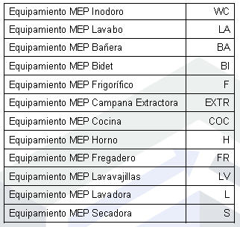

Example of MEP Equipment identifier for an Extractor Hood: MEP_MH_EXTR.01
Example of MEP Equipment identifier for a Refrigerator: MEP_EL_F.01
Example of MEP Equipment identifier for a Toilet: MEP_PB_WC.01

Format criteria: maximum length, case sensitivity, separators….

Multidisciplinary element identification and naming
This catalogue is the project information standard for model types in the disciplines contracted for this project. It is maintained by the BIM Manager and generated from MC. It applies to Revit type names, shared type parameters, schedules and IFC mapping.
Rules
- Each model type has a unique, machine-readable Type Code. The code is generated as Discipline-Category-Function-System-Variant-Dimension.
- Type Name is a clear human-readable description. It is not used as the sole identifier and it must not include level, room, building, block or instance location.
- An instance requiring individual traceability receives an Instance ID in the project Mark or agreed shared parameter. Instance IDs are not part of the type name.
- Only disciplines enabled in MC Team and contracted for the project are included in this catalogue. Category, Function, System, Variant and Dimension use the controlled values below. New values require BIM Manager approval before use in Shared information.
- Codes use uppercase A-Z, numbers and hyphens only. Dimensions are expressed in millimetres unless the catalogue notes otherwise. Classification is stored as a separate parameter and mapped to IFC where required by the information requirements.
- Before WIP information is shared, the task team checks that every listed type has a unique Type Code, a Type Name and the required classification.
Catalogue of contracted discipline element types
No. | Discipline | Category | Function | System | Variant | Dimension mm | Type Code | Type Name | Classification | Notes
{{ELM_N}} | {{ELM_DISCIPLINE}} | {{ELM_CATEGORY}} | {{ELM_FUNCTION}} | {{ELM_SYSTEM}} | {{ELM_VARIANT}} | {{ELM_DIMENSION}} | {{ELM_CODE}} | {{ELM_NAME}} | {{ELM_CLASSIFICATION}} | {{ELM_NOTES}}
Example interpretation: ARC-WAL-EXT-ME01-FFX-250 identifies an architectural exterior wall, system ME01, variant FFX, with a nominal 250 mm thickness. Its readable Type Name may be “Exposed brick facade 250 mm”.
 | Format criteria
IN GENERAL | The allowed separators are:  .dot  –hyphen  _underscore  Do not use Ñ, accents, ¿…

For type marks, the maximum length is 7 case-sensitive (letters or numbers) plus necessary separators. Never longer than this.
For Type Names, the length depends on the description. Of course in SD, it must be as brief as possible.
As case sensitivity, we use mainly uppercase letters and numbers.
As separators: -hyphen / _underscore / .dot / ()parentheses
We will not use Ñ, accents, or ¿?

COMMUNICATION CRITERIA.
The BIM methodology is largely based on interoperability between the different agents, so it is essential to establish agile and efficient communication channels and protocols.
To meet this need for information transmission, beyond that already transferred through the working files, there are different tools that allow the different agents to communicate with each other in order to resolve the doubts and issues that arise during the process. This point defines these communication tools and protocols.

Protocols and tools for communication and coordination between the project agents.

Communication between members in the general project organization environment.
The project tasks or areas, as well as the agents responsible for each of them, have been defined in point A.2. According to the BIM uses and the responsible agents, the different MILESTONES are related in the Process Map, which will be fully defined in the BEP.
When the project starts, the BIM Coordinator is first responsible for creating the folder structure in the common working environment, cloud server, according to the folder structure defined in point A.6.
They are also responsible for ensuring that each team member has the information and documentation necessary to develop their work in each project phase. This base information must appear in the TRELLO board corresponding to each project and is accessible to all team members.

They manage the permissions for each team member, free or limited access.
All team members have access to all the folders considered necessary for them; if they need any additional information, they request it from the BIM Coordinator.

Communication tools during work development (WIP)

SLACK


The BIM Coordinator creates the channels necessary for communication between team members. They make the invitations to each channel and indicate the instructions and rules for using them. The BIM Coordinator must set the specific channels for each project discipline and establish, inside and outside the team, which members participate in which channels. They must also perform moderation work.

IN-PERSON OR VIDEOCONFERENCE MEETINGS

All in-person meetings are held at the Architecture office.
For videoconference meetings, the Hangouts tool is used.
Meetings are planned via GOOGLE CALENDAR and the BIM Coordinator notifies the appropriate channels for the members' awareness.



The conclusions are recorded in the corresponding Minutes based on the template available in the CDE. They are published in their corresponding folder, for consultation by the rest of the team members.
These minutes are filed in a folder named Minutes, and are named with Project Code, Phase, Developer's Minute number, date. The frequency of these meetings is not fixed, and is set by the developer itself or by the project needs as defined by the BIM Coordinator.Organizational meetings have a fixed date on the calendar set by the BIM Coordinator.

TRELLO

The BIM Coordinator creates the project in Trello and invites the team members.
For each discipline they create the corresponding boards. Likewise, there is a 00 INFORMATION board showing the project's basic data for access by its members.

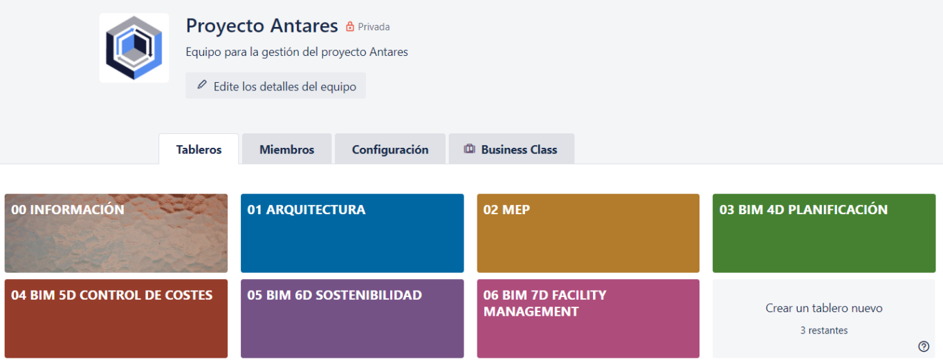

TRELLO - CLARIFICATION REQUESTS / PROJECT INFORMATION

The BIM Coordinator creates a specific list for Project Clarification Requests (SAP) or Project Information Requests (SIP) within each discipline board.
In this list, each member who needs to creates the card corresponding to their information or clarification request, tagging it accordingly (if it is an additional information request, with the SIP tag, and if it is a clarification, with the SAP tag).
The member who creates the card assigns it to themselves and to the BIM Coordinator, who receives the notification of having been added to the card.
They review its content and, where appropriate, add the member who is to provide the information, setting a due date, attaching the documentation they deem necessary and making the appropriate comments.
Within the cards, a communication thread can be created between the members attached to it.
Once the request has been resolved, the card is dragged to the RESOLVED REQUESTS list.
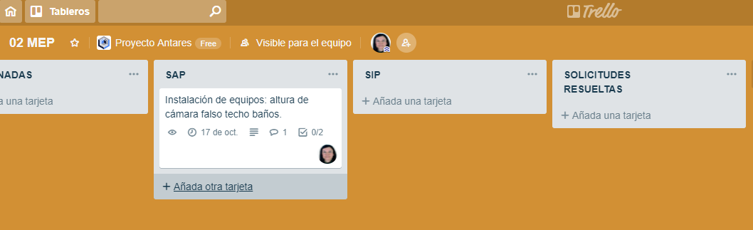

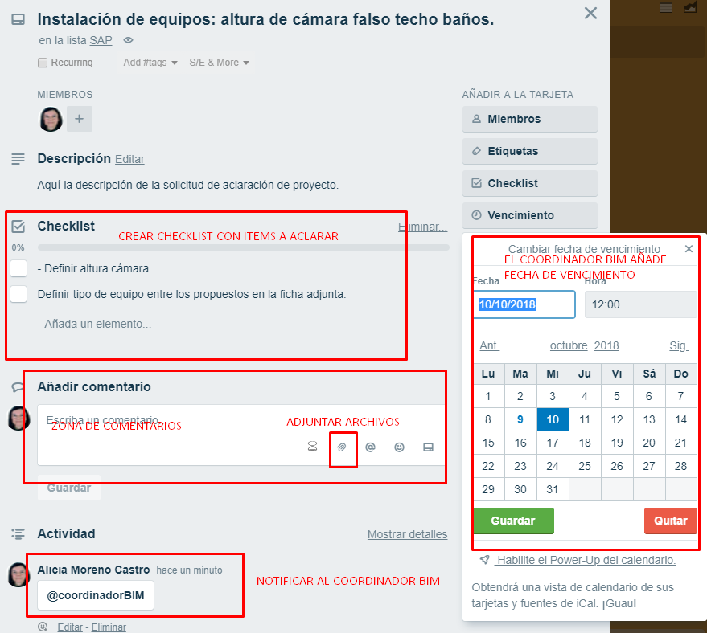

TRELLO - COMMUNICATION DURING WORK EXECUTION

Task execution
Tasks are established from the original model and assigned by the BIM Coordinator to each team member, who must complete it in due time and form.
Completed tasks are marked only by the Coordinator once their completion has been notified and supervision by the Coordinator or the designated responsible person has taken place.

Quality control
For task review, the BIM Coordinator determines which team member must supervise it.
When the set of tasks of a board is completed, the BIM Coordinator validates it, moving the card to completed.

Communication between organization members during model quality control.

BIM Collab BCF Manager

For communicating issues (clashes/collisions), the BCF Manager add-in of the BIMCollab platform installed in Navisworks is used.
The BIM Coordinator establishes the responsible person who must supervise the issues and ensures that the necessary feedback occurs so that the issue is resolved in the corresponding discipline.

Project interoperability and quality control protocol. Review and Co-Design.

Coding for synchronizing the local copy with the central model. Traceability. History.
#new | Creation of new model elements.
#mod | Modification made to the model.
#del | Model elements deleted.
#vis | Visibility tasks (object style changes, crop regions, etc.)
#und | Return to previous situations.
#doc | Model documentation tasks (dimensioning, composing sheets, legends, color schemes, tagging, rendering, etc.)
#rev | Review, error detection, leaving text comments for others, coordination monitoring.
#tab | Create, modify schedules.
#fam | Family management.
#inf | Global model information management (project information, shared parameters, project parameters, location, orientation.)
#stp | Pause or interruption in the work
#err | Correction of detected errors.
#var | Several operations performed (avoid as far as possible).
#tst | Test, trial of a solution (avoid as far as possible).

With the Show History tool, the BIM Coordinator can track the work done and the modifications.
The BIM Coordinator determines whether any of the actions must be reviewed.
Each team member must notify the BIM Coordinator of the completion of their tasks so that they can review the history and validate the task.

Organization and documentation generated in the model quality control at each project phase. Responsible. Traceability.

QUALITY CONTROL WITH REVIT

Tools of the coordinate group on the collaborate tab:
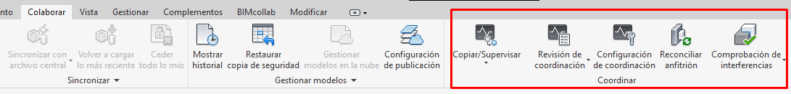

The Copy/Monitor tool is used to monitor the minimum number of changes required to coordinate the work of the different teams. If the Copy/Monitor tool is used too much and without careful planning, this could affect performance. Therefore, the Coordinator sets the frequency of use of this tool, which, in any case, must be set at least each time and always before the coordination meeting established in GOOGLE CALENDAR takes place.

PROJECT QUALITY CONTROL WITH THE NAVISWORKS TOOL.

For detecting CLASHES BETWEEN THE ARCHITECTURAL MODEL, THE STRUCTURAL and the MEP, the following procedure is followed, to be carried out by each specific discipline lead:

- Export the architectural model to Navisworks.
- Open the exported architectural model (*.nwc) in Navisworks and save it.
- Add the structural model.
- Activate the Clash Detective tool, add rules for clash detection.
- Run the test.
- Issue a report in HTML (tabular) format. See

The issues are exported from Navisworks with the following default options.

- Before importing, configure the BIMcollab options: conflict type, area, clash assignment, Milestone, etc.
- Manage the issues from BIMcollab.
- Resolve issues in the modeling platform with the BIMcollab add-in for Revit.
- Export the model with the modifications back to Navisworks.
- Update the information in BIMcollab.

Quality control history in Navisworks.
The BIM Coordinator reviews the history in Navisworks and, once the issues are detected, uses the corresponding NAVISWORKS verification system so that each member proceeds to resolve them.
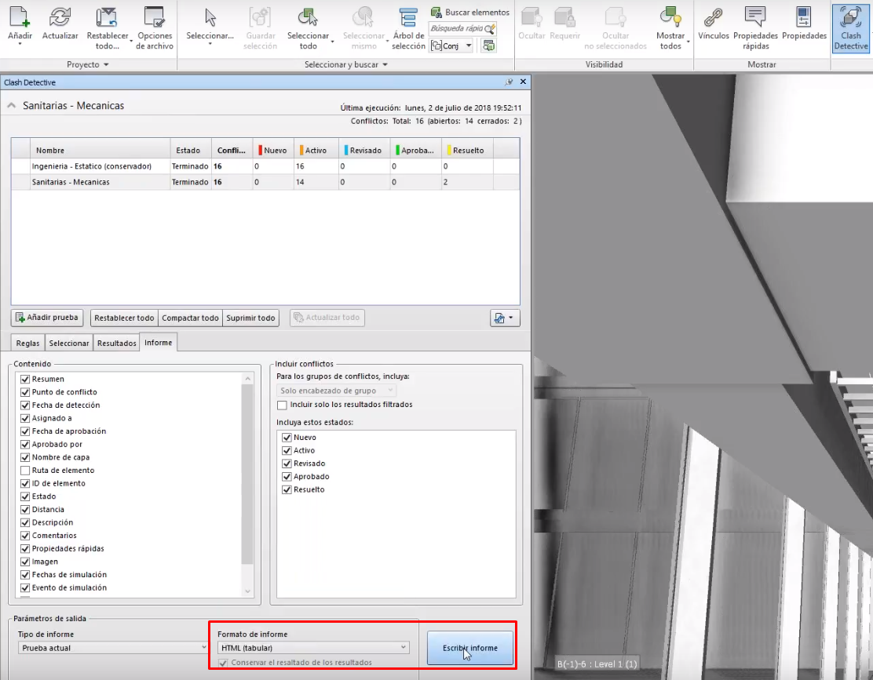

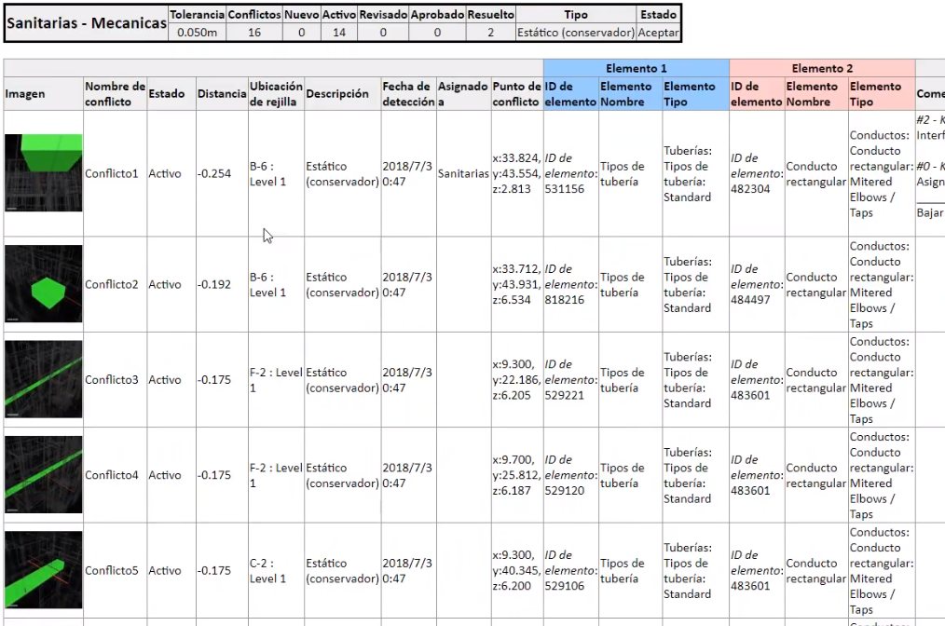
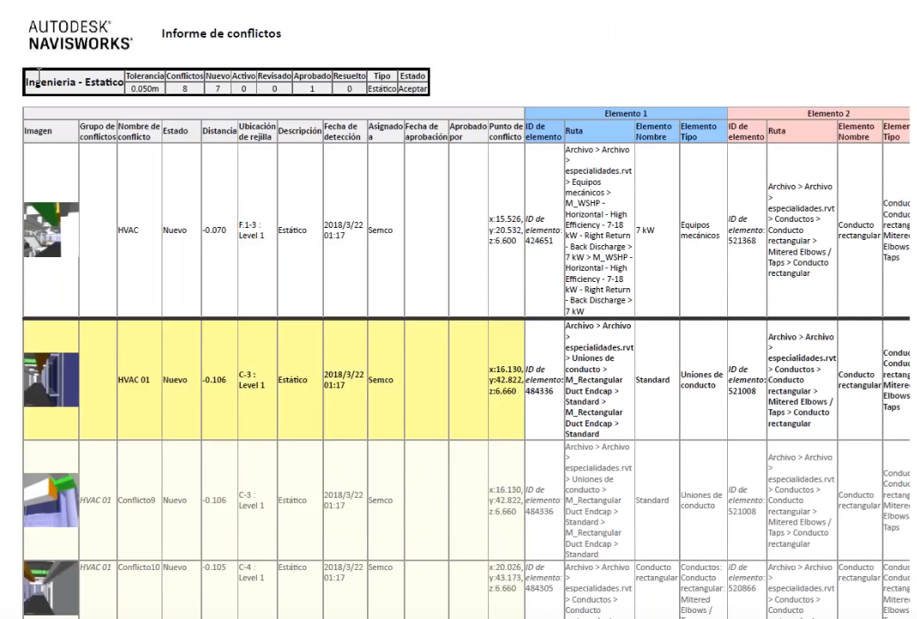

PUBLICATION CRITERIA.
The purpose of producing a BIM model is the use of the information integrated in a complete and structured database for collaboration between disciplines. Publications can be shared in multiple formats: 2D graphic information, 3D models, lists, technical information, images, etc.
The reliability of the published information depends on the established procedures not losing or distorting the information. This section defines the types of publications, formats and printing, export and publication protocols.

Protocols and documentation to publish during each project development stage. Deliverables.
Each project phase has an associated delivery of documentation and editable models. As a general rule, each document delivered must meet minimum quality guidelines in its format.
Identification data,
It must contain the data established in the 0. INFORMATION board of TRELLO
File size
The file size is adjusted as much as possible to avoid storing unnecessary information. Information irrelevant to the model must be deleted.
Content
A PDF file must be generated with the finished model following the determined presentation and information guidelines, which must be saved in its corresponding folder with the appropriate coding. This must be done with each completed phase.

Deliverable models and documentation.
In this section we define the list of models and documents that must be delivered.
It is useful to follow this list, which is reflected in a control document. It contains and meets the requirements of the client's contract or specification, as well as the documents required by the bodies where the project must be approved: professional associations, Town Hall and others.

List of deliverable documentation
DETAILED DESIGN
{{CODE}} | PLURIFAMILY HOUSING BUILDING {{PROJECT_NAME}}
CODE | DOCUMENT | FILE NAME* | CURRENT VERSION | PUBLICATION DATE
 | PDF DOCUMENTS
 | DETAILED DESIGN DOCUMENTS
1 MEM | REPORT | {{CODE}}-E-1 REPORT | WIP
2 PLI | SPECIFICATIONS | {{CODE}}-E-2 SPECIFICATIONS | WIP
3 PRE | QUANTITIES AND BUDGET | {{CODE}}-E-3 BUDGET | WIP
4 PLA | DRAWINGS
0 | REFERENCE DRAWINGS | {{CODE}}-E-4 PLA 0 REFERENCE | WIP
A | ARCHITECTURE DRAWINGS | {{CODE}}-E-4 PLA A ARCHITECTURE | WIP
E | STRUCTURE DRAWINGS | {{CODE}}-E-4 PLA 0 STRUCTURE | WIP
I | MEP DRAWINGS | {{CODE}}-E-4 PLA 0 MEP | WIP
 | COMPLEMENTARY DOCUMENTS
EE | ENERGY EFFICIENCY CERTIFICATE | {{CODE}}-E-EE ENERGY EFFICIENCY CERTIFICATE | WIP
O1 | WASTE MANAGEMENT STUDY | {{CODE}}-E-O1 WASTE MANAGEMENT | WIP
O2 | USE AND MAINTENANCE MANUAL | {{CODE}}-E-O2 USE MANUAL | WIP
O3 | QUALITY CONTROL PLAN | {{CODE}}-E-O3 QUALITY CONTROL PLAN | WIP
O4 | EMERGENCY ACTION RULES | {{CODE}}-E-O4 EMERGENCY ACTION RULES | WIP
SS | HEALTH AND SAFETY STUDY | {{CODE}}-SS HEALTH AND SAFETY STUDY | WIP
 | DWG FILES
 | DETAILED DESIGN DRAWINGS
0 | REFERENCE DRAWINGS | {{CODE}}-E-4 PLA 0 REFERENCE | WIP
A | ARCHITECTURE DRAWINGS | {{CODE}}-E-4 PLA A ARCHITECTURE | WIP
E | STRUCTURE DRAWINGS | {{CODE}}-E-4 PLA 0 STRUCTURE | WIP
I | MEP DRAWINGS |  | WIP
 | RVT FILES
 | DETAILED DESIGN MODELS
0 | REFERENCE MODEL | {{CODE}}-E-0 REFERENCE | WIP
A | ARCHITECTURE MODEL | {{CODE}}-E-A ARCHITECTURE | WIP
E | STRUCTURE MODEL | {{CODE}}-E-E STRUCTURE | WIP
I | MEP MODEL | {{CODE}}-E-I MEP | WIP
 | IFC FILES
E | DETAILED DESIGN MODELS
0 | REFERENCE MODEL | {{CODE}}-E-0 REFERENCE | WIP
A | ARCHITECTURE MODEL | {{CODE}}-E-A ARCHITECTURE | WIP
E | STRUCTURE MODEL | {{CODE}}-E-E STRUCTURE | WIP
I | MEP MODEL | {{CODE}}-E-I MEP | WIP
 | DWF FILES
 | DETAILED DESIGN DRAWINGS
0 | REFERENCE MODEL | {{CODE}}-E-0 REFERENCE | WIP
A | ARCHITECTURE MODEL | {{CODE}}-E-A ARCHITECTURE | WIP
E | STRUCTURE MODEL | {{CODE}}-E-E STRUCTURE | WIP
I | MEP MODEL | {{CODE}}-E-I MEP | WIP

Table of project documentation to publish at each stage of its development.
The deliverable documentation in each project phase, as well as the models and other documents resulting from the information exchange, is duly reflected in the project BEP and follows the structure below. Those sections the BIM Coordinator considers appropriate are removed, for not having been contracted or not being necessary.

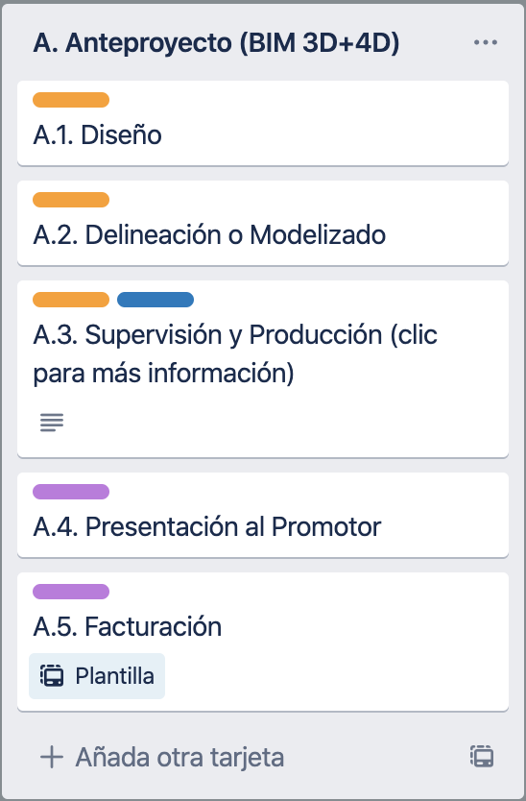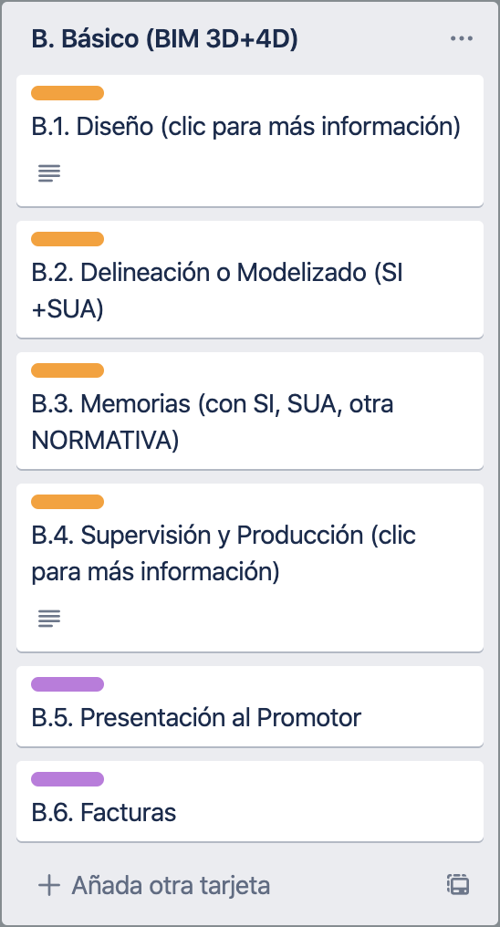

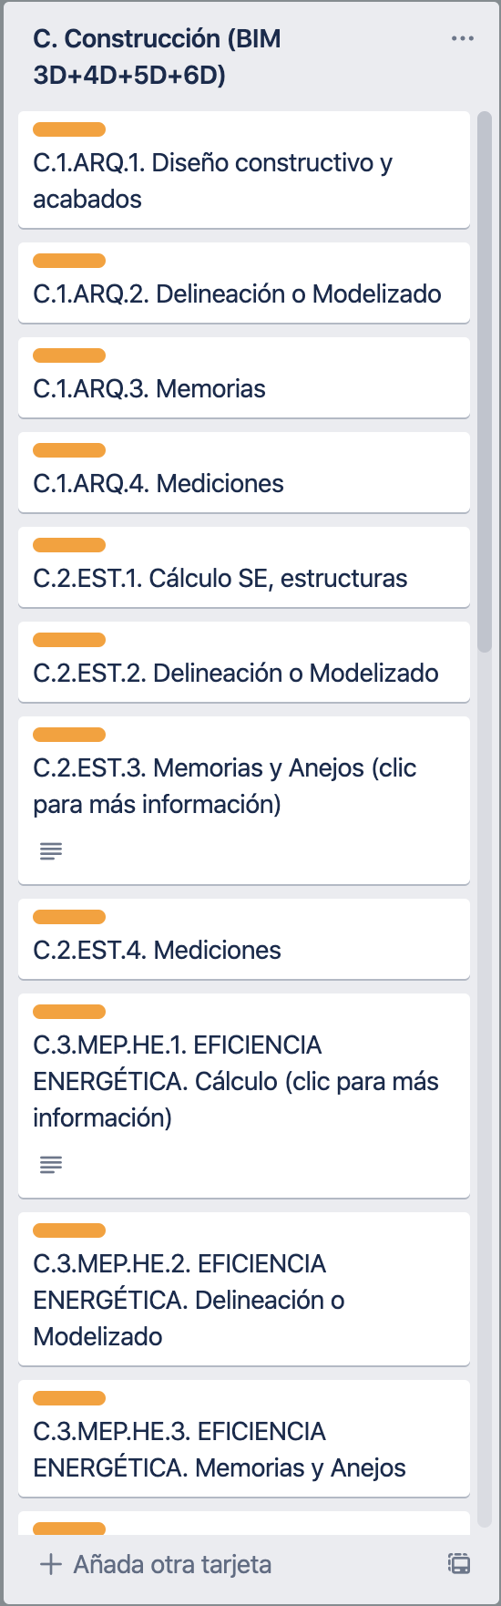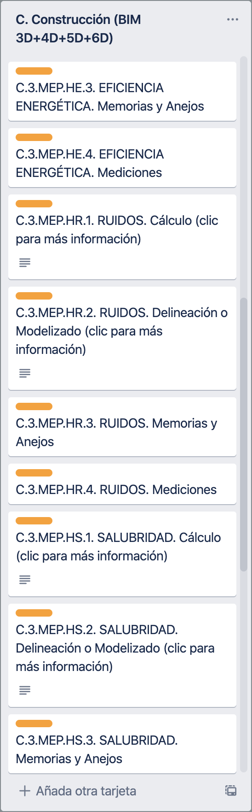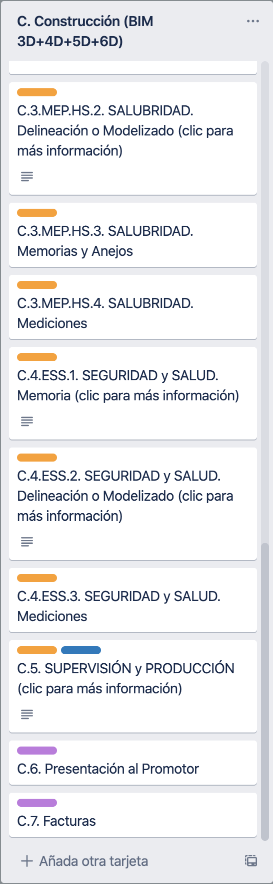

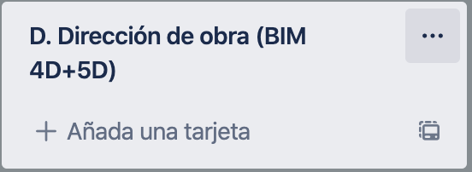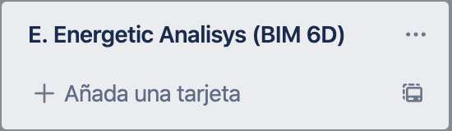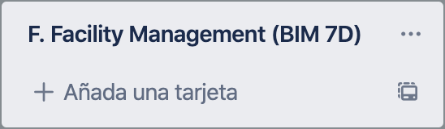

PDF printing
This point specifies the protocol for printing PDF documents. How, what, when, naming and storage.

Types of PDF prints

DELIVERABLE DOCUMENT PUBLICATIONS (versions)

The following list defines the types of documents that are part of the project structure. (E 1.2)
For example, we can consider a project documentation table:
We use a coding.
Report MEM, drawings PLA, specifications PLI, budget PRE, energy certificate EE…
They are saved in the VERSIONS folder of the project phase and are controlled in the document
{{CODE}}-E-VERSIONS
{{CODE}}-E-VERSION CONTROL.xls
{{CODE}}-E-PLA ARQ v1.0 181001.pdf

INFORMATION FOR COORDINATION WITH OTHER DISCIPLINES

Define the types of documents exported from the model (drawings and information lists, for example…)
{{CODE}}-E-EXPORTS
{{CODE}}-E-PLA ARQ 181001.pdf
For naming see A4- Project and control file naming; for filing see A6- File folder structure.

Sheet and view configuration for printing.
We define the format to use and the naming of the output document.
The format to use for publishing and printing drawings is that stipulated by ISO 216, which is based on DIN 476. The formats to use are loaded in the project generated from the RTE template.

Sheet sets:
The publication of deliverable drawings is done through sheet sets generated in a single document, except when the developer or supervision requirements indicate otherwise. In that case, each discipline carries its identifier and there is a global sequential number, and the output is produced in a single file.

The sheet set is saved, in the corresponding folder,
[project code]-[Phase]-[DISCIPLINE]-[PLA]-[drawing number/name]-[version (only for deliverables)]-[year/month/day]

Example: {{CODE}}-E-ARQ PLA Ab ELEVATIONS 20-12-13.pdf
Sheet set of project {{PROJECT_NAME}}, detailed design phase, architecture discipline, drawing group Ab, elevations dated 13 December 2020; as it carries no version, it is not a PUBLICATION, it is a COORDINATION file.

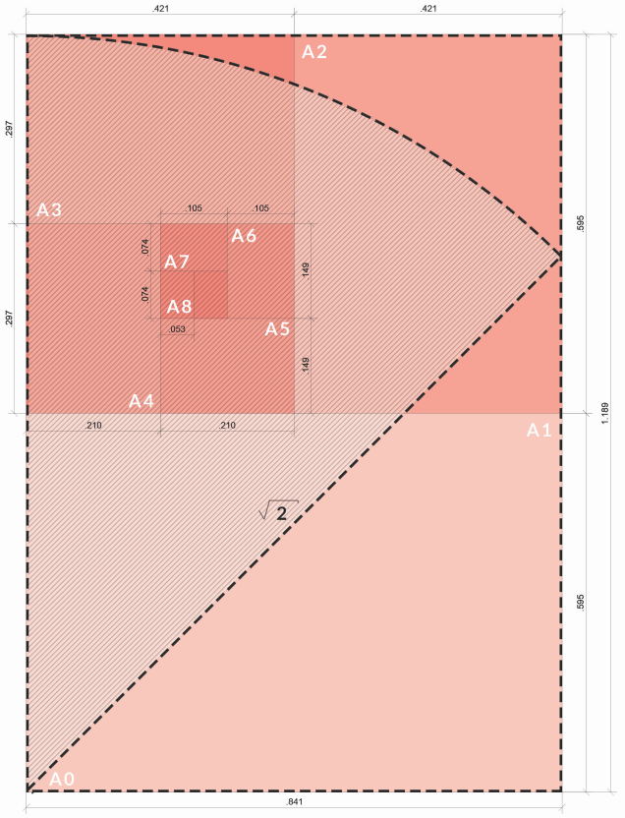
ISO 216, DIN 476 FORMATS
The format is a systemic derivation from a one-square-meter template in which each subdivision has half the area and also the same proportion between its sides. Thus, the A0 format is the one-square-meter base, A1 is half, A2 is a quarter, A3 is a quarter of the original piece, always preserving the same width-to-length ratio.

The configuration options, unless expressly indicated, are the following:
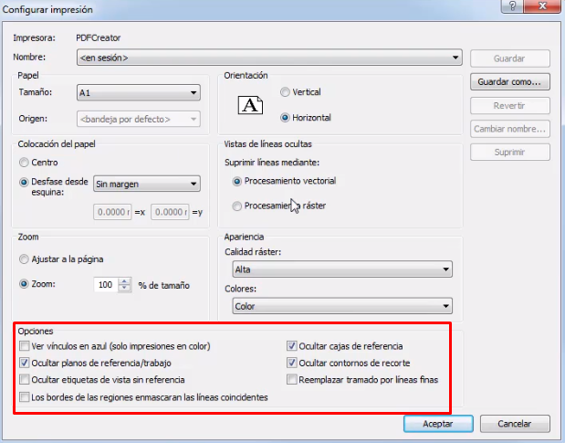
The print configurations are saved with a name explaining the print type.
Very important to check that the scale is 100%, do not fit to page.
Very important to check that vector processing is ticked.
The print configurations are saved with the following name:
(Format) A1, A2, A3…, (Orientation) H,V (Quality) HIGH, MEDIUM, LOW (COLOR/BW)
A4V-COLOR-HIGH

DWG exports
The configuration for exporting dwg files is defined.

Types of dwg files
DWG exports have two purposes:

DELIVERABLE DRAWING PUBLICATIONS (versions)
The drawings are generated in dwg without references and without hatching for delivery to the developer.

COORDINATION WITH OTHER DISCIPLINES
The dwg drawings are used as working templates for structure and MEP.

EXPORT FOR WORKING WITH NON-IFC MEP SYSTEMS OR WITH COMPATIBILITY PROBLEMS
The dwg drawings are used as base plan templates for structural calculation and MEP design.

General recommendations for a correct export:
- The AIA (American Institute of Architects) layer criterion is used
- Elements are modeled in their correct category; pay special attention to singular elements: (railings, lightweight enclosures, components, louvres…)
- No hatching is generated in the dwg export.

IFC exports
The configuration for exporting each model in IFC format is defined, according to its purpose.

Preparing the view to export
IFC exports have two purposes:

DELIVERABLE MODEL PUBLICATIONS
The model is delivered to the developer in IFC format and video on an IFC base for visualisation.

COORDINATION OF WORKING MODELS BETWEEN DISCIPLINES
IFC is used to coordinate the architecture discipline with structure and MEP.

The IFC models are generated for their import and synchronization with the CYPECAD and CYPECAD MEP calculation programs at LOD 200, never at a higher definition level. The BIM Coordinator and the BEP lead determine whether it is necessary to modify the LOD level for each installation.

IFC export configuration of the structural model.

For exporting the Revit model to Cypecad for structural calculation, a 3D View is saved:
Discipline: ARCHITECTURE
{{CODE}}-view-use: 2 EXPORTS
Family 3D
View type configured with the view template {{CODE}}-EXP-RVT-CYPECAD

An IFC is exported from this view. The CYPECAD IFC4 export template, which comes in the model template, is chosen. The resulting IFC is saved in the corresponding project phase folder.

Below, an example of the interoperability sheet we will have in the BEP:

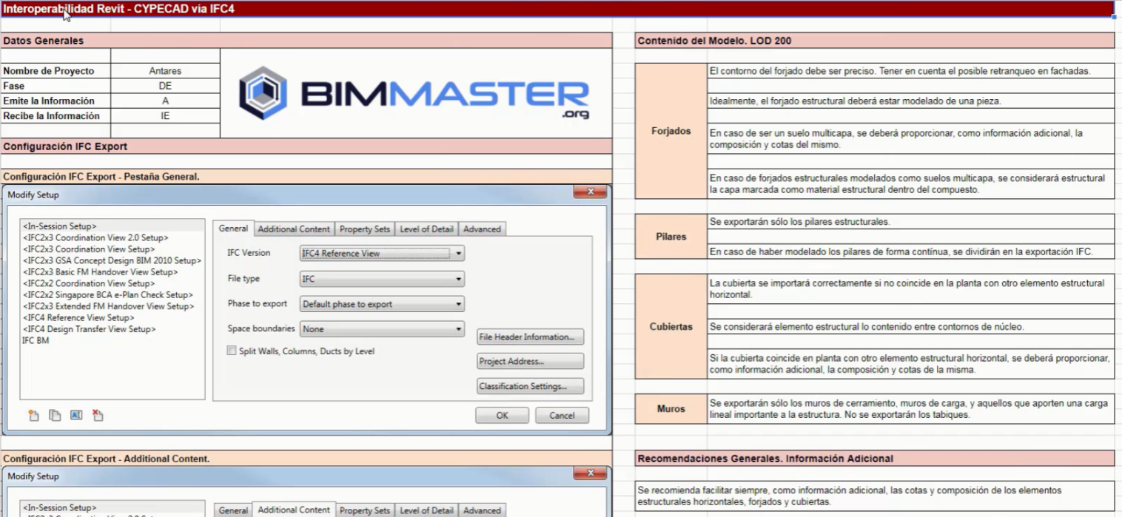

Element | Modeling criteria and elements of the 3D export view REVIT to Cypecad at LOD 200
Slabs | The slab outline must be precise.  The slab must take into account the façade setback.  The structural slab is modeled as a single piece.  If it is a multi-layer slab, an additional information sheet must be provided with the composition of the horizontal cladding layer over the slab or roof, its thickness and finish level.  For a multi-layer slab, the layer marked as structural material within the composite is considered structural
Columns | Only structural columns are exported.  Columns are modeled by floor.
Walls | Only enclosure walls and load-bearing walls that provide a significant linear load to the structure are exported. Interior partitions with a total thickness under 18 cm are not exported.
Roofs | The roof will import correctly if it does not coincide in plan with another horizontal structural element  The content between the core outlines is considered structural.  If the roof coincides in plan with another horizontal structural element, the composition and levels of these must be provided as additional information.

IFC STR EXPORT CONFIGURATION - GENERAL AND ADDITIONAL CONTENT TAB
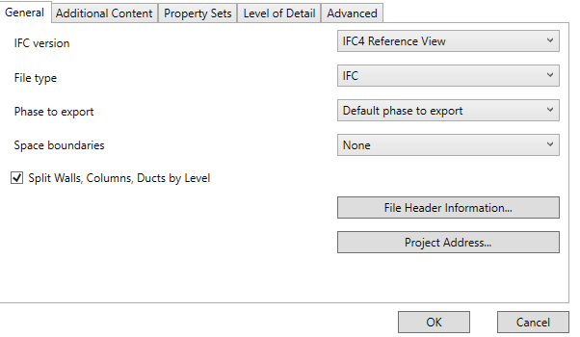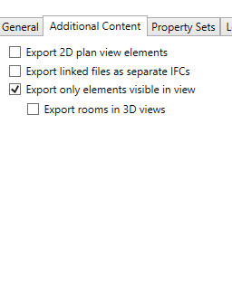

IFC STR EXPORT CONFIGURATION - PROPERTY SETS AND LEVEL OF DETAIL TAB
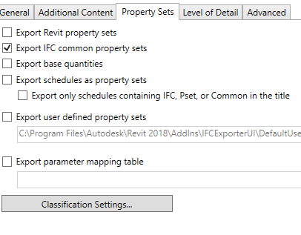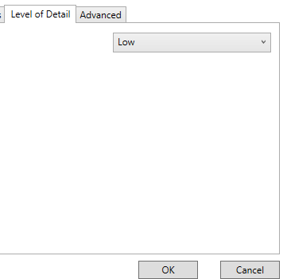

IFC STR EXPORT CONFIGURATION - ADVANCED TAB
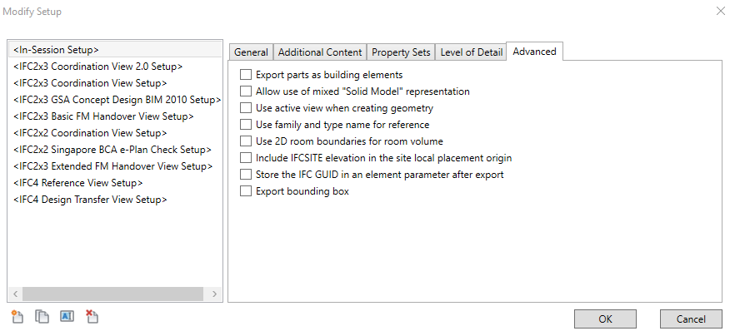

IFC export configuration of the architectural model.

For exporting the Revit model to Cypecad MEP for modeling the services, a 3D View is saved:
Discipline: ARCHITECTURE
{{CODE}}-view-use: 2 EXPORTS
Family 3D
View type configured with the view template {{CODE}}-EXP-RVT-MEP

An IFC is exported from this view. The MEP IFC4 export template, which comes in the model template, is chosen. The resulting IFC is saved in the corresponding project phase folder.

As in the previous section, the interoperability sheet for the MEP discipline that must be met will be developed in the BEP.

DWF publication
DWF publications are non-editable 2D or 3D files that contain model design data and can be shared with project agents who do not have AutoCAD or Revit tools. They can be viewed with free viewers such as: Autodesk DWF viewer.

Types of DWF
DWF exports have two purposes:
DELIVERABLE MODEL PUBLICATIONS:
To be presented to the developer, contractor and builder. For other agents, the BIM Coordinator decides.
PROJECT STATUS INFORMATION during its development
For naming see section A4-Project and control file naming; for filing see A6-File folder structure

Export view configuration
For exporting the Revit model to DWF for model visualisation, a specific 3D View is saved with the special export characteriztics:
Discipline: ARCHITECTURE
{{CODE}}-view-use: 2 EXPORTS
Family 3D
View type configured with the view template {{CODE}}-EXP-DWF
View name e.g. +00 level AXO or GENERAL WITHOUT SITE WORKS or GENERAL

Export procedure
The same procedure as in the other exports is followed; an export configuration can be saved.

Observations:

- Instance properties are exported for all types of shared, project, family and system parameters
- Type properties are exported only for system parameters.
- Type properties are not exported for project, shared or family parameters.

